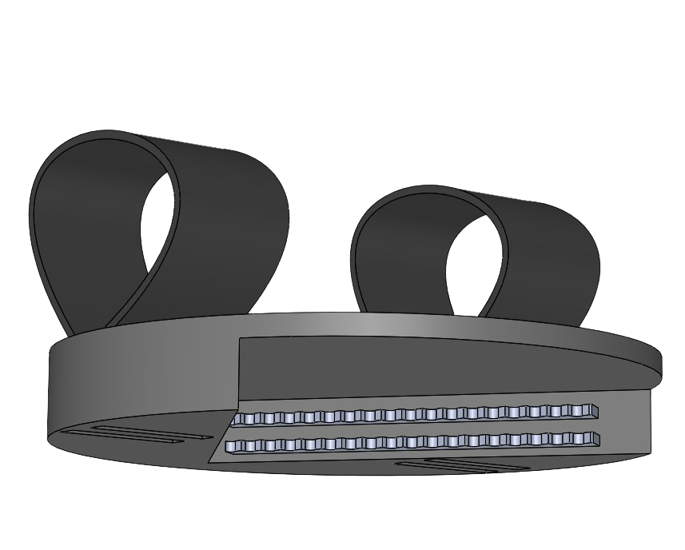

MiCO

My Instant Container Opener

**Prepared For:** Ms. Meghan Griffin and Ms. Randi Applehans

Shirley Ryan AbilityLab

**Date:** December 4, 2021

**Submitted By:** Ahmad Alhayek, Isa Candal, Lainey Neild,

and Nicholas Wolanske

DTC 1, Section 8, Team 1

**Sponsored By:** Design Thinking and Communication Program

Professors Megan Geigner and Cristabel Ramos-Tirado

McCormick School of Engineering and Applied Science

Northwestern University

# Acknowledgements

Special thanks to Northwestern University Design Thinking and Communication Professors Megan Geigner and Cristabel Ramos-Tirado, Northwestern prototyping specialist Heidi Huckabay, and Shirley Ryan AbilityLab project partners Meghan Griffin and Randi Applehans.

The contents of this report were developed under a grant from the National Institute on Disability, Independent Living, and Rehabilitation Research (NIDILRR grant number 90REGE0010). NIDILRR is a Center within the Administration for Community Living (ACL), Department of Health and Human Services (HHS). The contents of this report do not necessarily represent the policy of NIDILRR, ACL, or HHS, and you should not assume endorsement by the Federal Government.

# Executive Summary

Near-lethal experiences, such as surviving a gunshot wound to the spine, bring a magnitude of new challenges to the survivors, including our client at Shirley Ryan AbilityLab. Our client, Igor, now uses a wheelchair and needs a new solution for opening containers and jars. Reduced strength and limited movement inhibit the user’s ability to open a variety of containers from toothpaste bottles to peanut butter jars. Moreover, existing market solutions have proved unfavorable and difficult for Igor.

Ms. Meghan Griffin and Ms. Randi Applehans of the Shirley Ryan AbilityLab, both of whom are occupational therapists working directly with the user to get him back into his everyday life, approached us with a challenge: to design a discreet, portable, lightweight device that could open or loosen a magnitude of containers for the user. After conducting numerous rounds of constructing low-fidelity mockups and performance testing, our team consulted with Meghan and Randi, Northwestern professors Megan Geigner and Cristabel Ramos-Tirado, and Northwestern prototyping specialist Heidi Huckabay. Development of our final solution includes both a computer model and physical prototype developed from an existing market solution, both of which underwent various testing.

Our solution is MiCO: the **M**y **I**nstant **C**ontainer **O**pener. MiCO brings a unique perspective to the container-opening game. Building off an existing market solution designed to help elderly people with arthritis open containers, MiCO optimizes this product for a user in a wheelchair. Our solution consists of one main assembly— a plastic disc with metal teeth for traction with Velcro on top to securely attach to the armrest— and an optional, protective safety sleeve.

The user will attach the two Velcro straps around the wheelchair’s armrest tightly and grab the base of the container they are trying to open. They then place the lid of the jar in the triangular opening, in contact with the two metal blades, and twist their wrist in a circular motion, thereby loosening the lid with MiCO. MiCO’s sleek and compact design make it a favorable choice our user who wants to keep a low profile while overcoming the challenges his situation throws at him and gaining more independence in his everyday life.

Table of Contents

Acknowledgements 1

Executive Summary 2

List of Figures 7

List of Tables 10

Introduction and Background 11

Story of More 11

Existing Solutions 12

Users and Stakeholders 13

User Profile 13

Illustrative User Scenario 14

Mission Statement 14

Project Requirements 14

Design Concept and Rationale 16

Part 1: The Circular Base 17

Part 2: The Blades 19

Part 3: The Velcro 20

Part 4: The Protective Sleeve 21

Instructions for Use 23

Limitations 26

Conclusion 27

Directions for Future Development 28

Appendix A: Project Definition 29

Mission Statement 29

Project Deliverables 29

Constraints 29

Users and Stakeholders 29

User Profile 30

Illustrative User Scenario 30

​Project Requirements 31

Appendix B: Research Appendix 32

Primary Research: Project Partner Interview 32

Methodology 32

Introduction and Project Partners 32

Overall Needs 32

Current Solution 32

User Information and Preferences 33

Primary Research: Proxy User Interview 35

Methodology 35

Introduction of Proxy User 35

Current Solution 35

Previous Solutions 35

Secondary Research Summary 37

Overview 37

Anatomy and Kinesiology 37

Stroke and related injuries 40

Existing Solutions 41

Materials 43

Team Discussion 46

Appendix C: User Observation 47

Observation 1: Videos of the User Opening Containers 47

User Observation Summary 47

Methodology 47

Information about the User and His Wheelchair 47

User’s Interactions and Difficulties Opening Containers 48

Discussion 50

Appendix D: Mockup Appendix with User Feedback 51

Methodology 51

Mockups 51

Criss Cross Container De Coupler 51

Rocking Ratchet Wrench 53

Zip Time Cup Holder 54

Rubber Clamp Cup Holder 55

The Air Pressure Device 56

The Clasp and Lock 57

The Tablelike Opener 58

The Underarm Rest Jar Opener 59

Iteration 60

Discussion 61

Appendix E: Instructions for Construction and Bill of Materials 62

Instructions for Construction 63

Preparing the materials 63

Fabricating the device 63

Bill of Materials 72

Appendix F: Stress Testing 73

Appendix G: Mockup Consultation 76

Mockup Consultation 1: Interview with Heidi Huckabay 76

Methodology 76

Initial Commentary 76

Mockup Overview 76

Mockup Review 76

Appendix H: Performance Testing 78

Prototype Testing 1 78

Introduction 78

Methodology 78

Task One: Large Jar 79

Task Two: Medium-Sized Container 80

Task Three: Pill Bottle 81

Appendix I: Design Review Summary 84

Design Review 1: Feedback 84

Methodology 84

Plan to address these reviews 85

References 86

Main Report 86

Appendix B: 87

# List of Figures

Figure 1: Dycem® [1] 12

Figure 2: Automatic Jar Opener® [2] 12

Figure 3: EZ OFF Jar Opener® [3] 12

Figure 4: A Sideview of a CAD Drawing of MiCO 16

Figure 5: An Angled View of a CAD View of the full MiCO assembly. 17

Figure 6: A view of the bottom of MiCO (the side that sits under the armrest), shown with the four cutouts for the straps and the blades. 18

Figure 7: A Closeup of the Blades 20

Figure 8: A Top View of MiCO Attached to Armrest 20

Figure 9: A Side View of MiCO Attached to Armrest 20

Figure 10: MiCO’s PEEK protective sleeve, as described in Part 4 21

Figure 11: How the MiCO Should be Placed onto the Armrest 23

Figure 12: Pulling the Velcro to Secure the Device onto the Armrest 23

Figure 13: Bottom Side View of How the Cap should be Placed on the Device 24

Figure 14: Movement with the Container once in the MiCO 25

Figure 15: A View of Hand Anatomy [B2] 37

Figure 16: Illustrating Different Types of Grips in Children and Toddlers [B5] 38

Figure 17: A View of Power and Precision Grips [B1] 39

Figure 18: An Informative Infographic Relating to Stroke [B9] 40

Figure 19: A View of the Nerves Extending into the Arm [B11] 41

Figure 20: Dycem Non-Slip Self ®[1] [B15] 41

Figure 21: Dycem Non-Slip Cone® [B16] 42

Figure 22: Under the Cabinet Jar Opener [3] 42

Figure 23: Jar Key Container Opener [B17] 43

Figure 24: Automatic Jar Opener [2] [B18] 43

Figure 25: Round Silicone Trivets, Pamolon, Round Silicone Trivets, model: YQ-1250 [B19] 44

Figure 26: A Front View of De Coupler 51

Figure 27: A View Inside De Coupler 52

Figure 28: The Stick base 53

Figure 29: The Ratchet Wrench 53

Figure 30: The Zip Tie Cup Holder Without Contents 54

Figure 31: The Zip Tie Cup Holder in Use 54

Figure 32: A View of the Rubber Clamp Opened 55

Figure 33: A View of a Container Gripped by the Clamp 55

Figure 34: A Top View of the Air Pressure Device 56

Figure 35: A Side View of the Air Pressure Device 56

Figure 36: A Side View of the Air Pressure Device with a Container 57

Figure 37: A Top View of the Air Pressure Device with a Container 57

Figure 38: An Angled View of the Clasp and Lock 57

Figure 39: The Clasp and Lock Engaged 58

Figure 40: The Clasp and Lock in Resting Position 58

Figure 41: A Top View of the Tablelike Opener 58

Figure 42: A Side View of the Tablelike Opener Engaged 59

Figure 43: A Front View of the Underarm Rest Jar Opener 59

Figure 44: The Underarm Rest Jar Opener Engaged 60

Figure 45: A Top View of the Underarm Rest Jar Opener 60

Figure 46: The Cut Plywood 63

Figure 47: The Uncut Plywood 63

Figure 48: The Device with Adhesive Removed 64

Figure 49: The Device with Adhesive Attached 64

Figure 50: The Device with Specified Line 64

Figure 51: The Device with Extra Material Removed 64

Figure 52: Sanding the Device 65

Figure 53: The Plywood Block Flush on Mill Pins 65

Figure 54: Labeled Mill Parts 66

Figure 55: Mill Studs and Pins in Place 66

Figure 56: The Device Clamped into the Mill 66

Figure 57: Labeled Mill Clamping Parts 67

Figure 58: The End Mill in the Mill 67

Figure 59: The Initial Zero Points 68

Figure 60: Milling the Device 68

Figure 61: The Finished Milled Device 69

Figure 62: Preparing the Device for Painting 70

Figure 63: The Device Hanging 70

Figure 64: The Force Distribution FEA Test on MiCO 75

Figure 65: The Results of the Displacement test on the MiCO assemble 76

Figure 66: Spray Painting the Device 70

Figure 67: Passing the Velcro Straps through the Device 71

Figure 68: The Finished Product 72

Figure 69: Chair Used as Testing Mechanism 79

Figure 70:Sequence of Opening the Large Diameter Container 80

Figure 71: Sequence of Opening the Medium Diameter Container 81

Figure 72: Sequence of Opening the Small Diameter Container 82

# List of Tables

Table 1: Project Requirements Summary 31

Table 2: User Observations without Dycem: Opportunities, Follow-up, Suggestions 48

Table 3: User Observations with Dycem: Opportunities, Follow-up, Suggestions 49

Table 4: Bill of Materials Used in Mockup Construction 62

Table 5: Bill of Materials for Mockup Testing 73

Table 6: Performance Testing Summary 83

Table 7: Design Review Summary 85

# Introduction and Background

## Story of More

In a world where every human does not yet have a personal robot to open containers for them, we face the daunting challenge of opening a pickle jar that just won’t open or a maple syrup jug whose lid has been sealed shut by too many sweet and syrupy pours. As we watch our pancakes cool down, we rush to grab a handy kitchen towel, run the jug under some hot water, or find a friend to assist. For those with limited arm mobility and grip strength, any container can become such a challenge.

Try opening a peanut butter jar with one hand and severely limited grip strength. Our user, an 18-year-old male who we refer to as Igor, faces that challenge every time he wants a PB & J. With limited grip strength and paralysis from the waist down and in his left arm, our user relies on ingenuity and determination to open that container. He tries to wedge the jar between his leg, push it against a counter, or, in last resort, call for assistance from someone else (see Appendix A: Project Definition and the Primary Research: Project Partner Interview in Appendix B for more). As the day goes by, he encounters the same issue repeatedly; every pill bottle, toothpaste tube or spice jar present the same tedious challenge. Our user, and those in a similar circumstance, require a device that will make the struggle of opening a container disappear.

In order to achieve such a result, the device needs to be discrete, efficient, and above all else, able to open a wide variety of containers with the use of only one hand (more on this in Appendix A: Project Definition). A device that is easy to clear, safe to use, and easy to store or attach. A device that brings joy and independence to the user, making that favorite PB and J sandwich so much easier to make.

The impact of such a design extends well beyond the user himself: his caregiver is no longer required to open a jar, his occupational therapists at the Shirley-Ryan AbilityLab are closer in their desire to give him greater independence, and, on a grander scale, individuals around the globe who find themselves in a similar circumstance, can open containers without hinderance or struggle.

## Existing Solutions

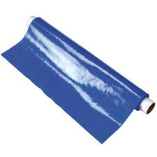Currently, numerous devices are available to purchase that assist in opening containers, but none completely satisfy the requirements of our project (see Project Requirements at the end of Introduction and Background and Appendix B: Research Appendix for a more detailed listing).

Dycem®, the most widely used solution as seen in Figure 1, is a gripping material which gives the user a firmer grasp of the container. However, Dycem® only increases the users grip of the object, it does not secure it on its own; for this reason, Dycem® alone does not fulfill our requirements.

Figure 1: Dycem® [1]

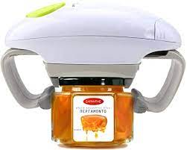Similarity, an Automatic Jar Opener®, seen in Figure 2, exists as another potential solution for the design challenge. Unlike Dycem®, the Automatic Jar Opener® is a device which grasps both the container and lid, and then uses a motor to twist the lid loose. While the device functions well on typical kitchen jars such as jam and tomato sauce, other containers including pill bottles and toothpaste could not be used by the device. For this reason, the Automatic Jar Opener® fails to meet all the project requirements.

Figure 2: Automatic Jar Opener® [2]

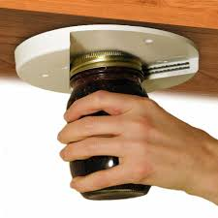

Lastly, the EZ OFF Jar Opener®, utilizes metal teeth to grip onto the lid of a container, allowing the user to twist it underneath and open the container. The V-Slotted design seen in Figure 3 allows for a wide variety of containers to be used with the product. However, the EZ Off Jar Opener® is intended to go underneath kitchen cabinets, not be transported around. Thus, although the device satisfies numerous design requirements, it lacks portability and discrete look required by the user.

Figure 3: EZ OFF Jar Opener® [3]

Therefore, every existing solution has a flaw (see Appendix B: Research Appendix for a full listing of existing solutions). Some are too expensive, and others non-portable. Some require a power source, and others are the equivalent of a wet towel. And the worst designs still require two hands; they only reduce the force required! Now the time arises to resolve the challenge of creating a device which assists in opening a container with just one hand.

## Users and Stakeholders

* The user, whom we shall refer to as Igor, will use the device to open containers independently
* Igor’s mother, who helps him open and close containers
* Ms. Randi Applehans and Ms. Meghan Griffin, the project partners, are occupational therapists who work with Igor to restore some habitual independence in his life

### User Profile

The user, Igor, is an 18-year-old male recovering from spinal cord and nerve damage because of gunshot injuries. Paralyzed from the waist down, Igor is confined to his wheelchair. He also has little to no movement of his left arm and reduced functionality of his right arm. Some of Igor's physical limitations include difficulty opening and closing his left hand, no mobility of sensation in his legs, a limited amount of grip strength, 10 pounds, and fine motor skills (see the Project Partner Interview in Appendix B: Research Appendix and Appendix C: User Observation for further detail on the user). However, Igor continues to have mobility and sensation on his left shoulder, elbow, and forearm and has control over his right hand, arm, and shoulder. He has no tremors or shaking and can press a lever or a button.

### Illustrative User Scenario

Igor lives with his mother who can assist in completing certain tasks. However, Igor wants more independence; thus, our device will ideally help him open containers and jars without help from anyone else. He spends most of his time in the wheelchair, so our design should either be able to attach and detach from the wheelchair or be able to be freestanding and small enough he can slip it into his backpack for school.

Currently, when attempting to open a pill bottle, Igor secures the pill bottle between his thighs and fingers on left hand. He grasps the top with a functional right hand and presses against it while twisting with his right wrist. However, since his left hand has no functionality, this does not work, and he fails to open it. To try to open a jar of peanut butter, Igor makes use of his elbow crease by placing the jar between his left upper and lower arm. He then presses against the top and twists his right wrist, but again it doesn’t work and just slips in his elbow. Unfortunately, Dycem, the existing material which Igor has been using that resembles a rubber pad, does not solve this problem. Igor uses the Dycem® by placing it in the palm of left hand and pressing the jar against it. Next, he tries to twist the top off with his right hand and wrist, but it still doesn’t give him enough traction and stability over the jar. Simply put, no existing solution works for Igor.

## Mission Statement

We aim to improve the ability of the user —a person with paraplegia in a wheelchair—to open containers with the use of only one arm.

## Project Requirements

While brainstorming solutions for our user, we compiled a list of needs to help focus our thoughts. The initial criteria we came up with included the following characteristics: lightweight, portable, subtle, and durable. After talking with Meghan and Randi and learning more about Igor’s experience, we decided that these components were the most important to prioritize in our final design. Further elaboration on the interview and important details we learned can be found in the Appendix B: Research Appendix, in the Primary Research: Project Partner Interview section. We also based some of the requirements from the user observations, as seen in Appendix C: User Observations, where we analyzed the user and his existing experience with containers. This helped us identify points of weakness in some of the products he used as well as understanding the mobility and constraints in movement that the wheelchair presents.

We started by researching the lightweight attribute. We all understood that the consumer must be able to lift the product with one arm, so we found that the ideal weight for our solution is about 0.5 pounds. In this way, we allow for the introduction of sturdy parts to our design. Then we set the maximum weight ceiling at 0.67, or two-thirds, of a pound, the point at which we decided our product would become too heavy for the user. In terms of volume, Meghan and Randi told us that our user should be able to carry the product in his backpack. So, we estimated the maximum possible size to be roughly 125” 3 (or about 5” x 5” by 5”) in volume, about the size of a small notebook or journal.

Next, our team started to brainstorm the style of our design. Meghan and Randi told us that Igor would not want a flashy design but rather something that is subtle and unobtrusive in form. We concluded that if the product was black or grey it would help keep it discreet. Additionally, we want to prioritize the sleek design to help it blend in in all circumstances and not draw much attention.

Finally, we had to think about the long term uses for our product. It would be quite unhelpful to Igor if it only worked one time. Ultimately, a primary goal for our group was that we create a reliable and durable product. After much debate, we agreed that an allowable lifespan would be 1-2 years because we figured we should allow some flexibility as we set out to test our product. We agreed on a guiding principle in the end: If the overall effectiveness of the product is affected by changes made to increase its durability, the effectiveness should be prioritized. See more about the results of mockup testing regarding our requirements in Appendix D: Mockup Appendix and User Feedback as well as Appendix I: Design Review Summary.

# Design Concept and Rationale

The final design for MiCO (My Instant Container Opener) consists of four main elements: a plastic base, steel blades, Velcro straps, and a storage sleeve. Together, these elements contribute to a powerful design that will aid Igor in opening various jars and containers. The circular base of the MiCO (illustrated in the various CAD drawings as varying shades of gray and white) has a diameter of 7” and is 1.25” in height. The two Velcro straps on top contribute an additional two or three inches in height; thus, the full assembly satisfies the original goal of minimalism and compactness (see Figure 4 for a CAD Drawing of MiCO).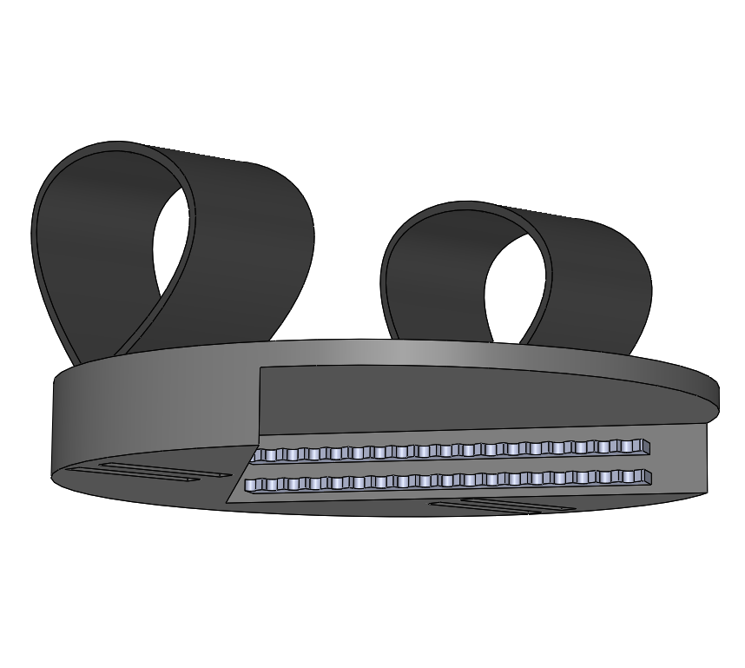 More detail about the final materials in our design are included in Appendix E: Bill of Materials. Details regarding stress testing of materials are in Appendix F: Stress Testing.

Figure 4: A Sideview of a CAD Drawing of MiCO

The user will unlatch the Velcro and place the circular base under the wheelchair’s armrest. Then, they or an assistant will tighten the two Velcro straps around the armrest, with the opening on the underside of the base facing their lap. The user will then place his desired container in between the teeth and plastic base, pushing until the lid firmly pushes against the blades, where the user will twist the container and MiCO will aid them in opening it.

The location of MiCO under the armrest provides the user with ample space for their legs and their container and leverages other upper body muscles and a rotational motion by crossing from their right to their left side. Finally, MiCO’s strategic location on the side opposite to the user’s dominant hand and within view of the user’s eyes make sure that the user can always see what they are opening with MiCO. The following sections will describe each individual component of MiCO and the rationale behind them.

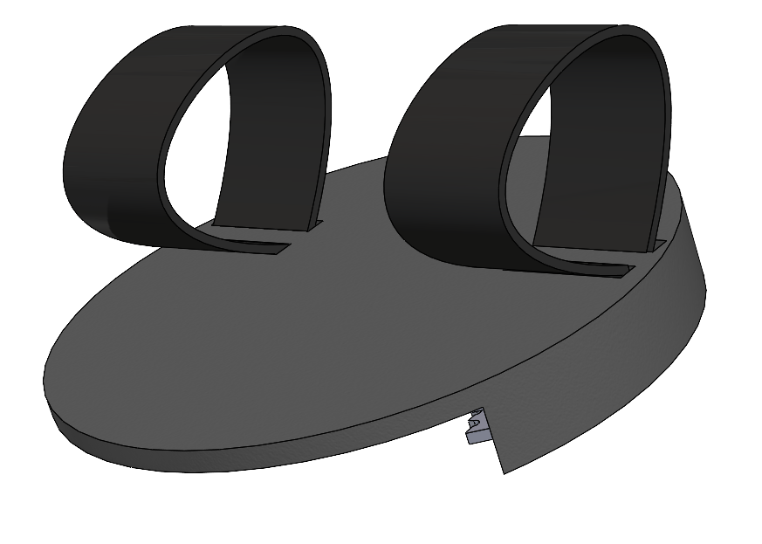

Figure 5: An Angled View of a CAD View of the full MiCO assembly.

## Part 1: The Circular Base

The first part of MiCO’s four-part system is the circular, plastic base (referred to as Part 1, as seen in Figure 5). The base measures 7” in diameter and 1.25” tall. The most crucial features of Part 1 include the triangular shape bottom, which allows the user to fit containers of varying radii, and the four slits on top (measuring 1.25” deep, 1.55” long, and 0.3” wide). At its widest, the triangular shape (see Figure 6) measures about 5” wide, enough to comfortably fit a jar of peanut butter [4]. At its narrowest, a bottle of toothpaste can securely fit within MiCO’s mouth [5].

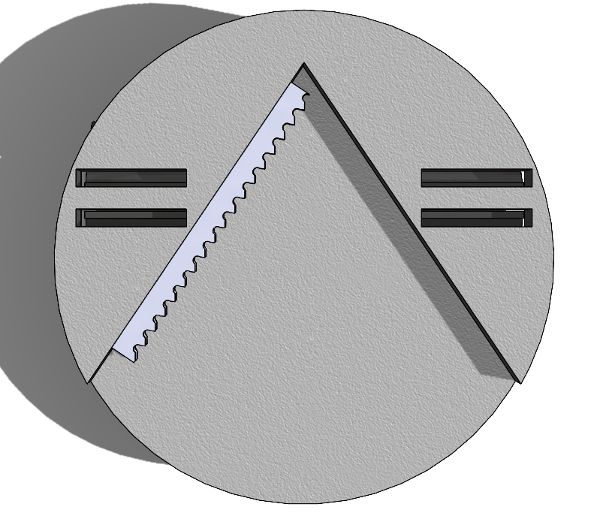The design team made a deliberate choice to resist the urge to hollow out the base to shave off weight, so that the base could have more points (greater surface area) in contact with the wheelchair armrest. Moreover, the section of Part 1 that sits above the blades and between the armrest ensures that the user cannot poke their fingers into the blades without knowingly doing so.

Figure 6: A view of the bottom of MiCO (the side that sits under the armrest), shown with the four cutouts for the straps and the blades.

Part 1 is made of polyether ether ketone (PEEK) plastic, a high-performance engineering organic thermoplastic [6]. PEEK retains incredibly high resistance to chemicals, wear, fatigue, and creep. Moreover, PEEK can be processed by conventional manufacturing methods, such as injection molding. Because of these properties, PEEK and variations of it are typically used in biomedical applications, making it suitable for use in MiCO [7].

Although relatively expensive compared to other injectable plastics, PEEK’s benefits make it well worth the cost. Still, PEEK retains an affordable cost— at $44 per pound of industrial-grade PEEK, and with our design remaining relatively light, creating MiCO out of PEEK plastic is a feasible approach [7].

For MiCO, we were certain of wanting to use some plastic for our base. Plastic is relatively inexpensive, easy to clean, and is lightweight, which are all factors we considered when first brainstorming for our solution (see Appendix A: Project Definition). Furthermore, plastic is easy to inject and modify, and easily accessible on the market for manufacturing. Overall, PEEK is a fantastic choice for Part 1 of MiCO.

## Part 2: The Blades

The blades of MiCO make the process of opening a container possible. Two sets of steel blades, placed about 0.4” apart on the interior of MiCO, provide enough friction to effectively loosen a lid off a container. The design of these blades (Figure 7 shows a closeup) resembles that of a saw blade. Within the 4.5” long blade, 18 teeth provide maximal integrity of the material while providing maximum contact with the container lid. With two blades, MiCO has 36 points of contact with the lid, providing ample friction.

The blades attach to MiCO’s base with adhesive glue, or an insert designed in the MiCO base (not present in figures). The steel alloy ensures hardiness and resistance to wear and rust and is easy to clean. Because of the numerous safety measures that MiCO employs, the blades do not pose a threat to the user.

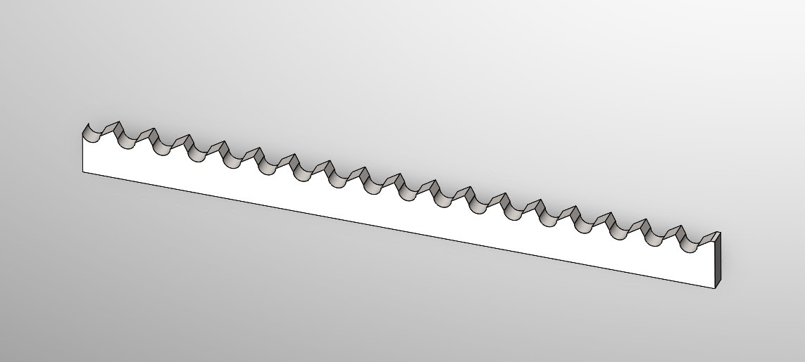

Figure 7: A Closeup of the Blades

## Part 3: The Velcro

Figure 8: A Top View of MiCO Attached to Armrest

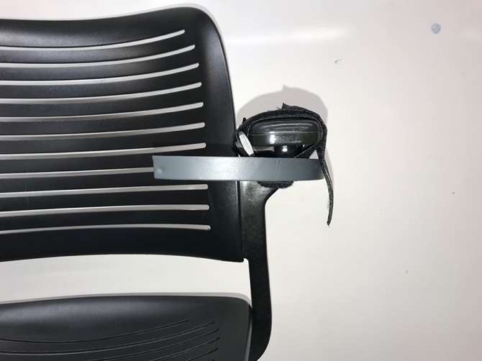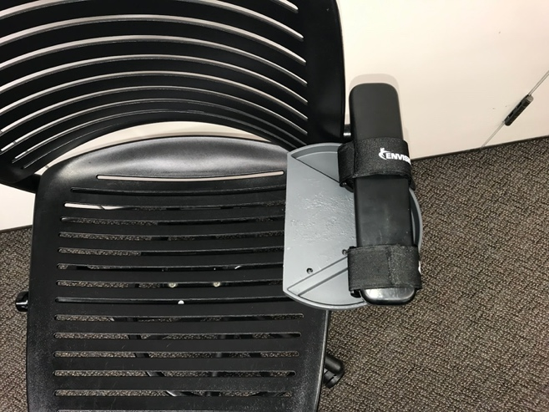The Velcro helps attach MiCO’s assembly tightly and securely to a wheelchair armrest for support (see Figure 8 and 9 for a physical prototype of MiCO attached to an armrest). The design team chose Velcro for this attachment mechanism because of its light weight and flexibility. The user can also attach and detach the device at any time they desire and can do so even with their existing physical limitations.

Figure 9: A Side View of MiCO Attached to Armrest

The Velcro straps attach through the four rectangular slits in Part 1 (see Figure 6). They stay on MiCO permanently yet are not a permanent fixture to the wheelchair. Their size can be adjusted depending on how tight the user wishes MiCO to be attached. The straps themselves are not large— only 1.5” in width, 12” in length, and a fraction of an inch in thickness, and weigh little. If they wear or tear apart, replacements can be purchased for less than $15 on Amazon or other online marketplaces. The Velcro straps adhere to Part 1 with adhesive glue, or by being tied around the slits.

## Part 4: The Protective Sleeve

Figure 10: MiCO’s PEEK protective sleeve, as described in Part 4

To safeguard against the steel blades, MiCO slides into a PEEK sleeve, like that of a computer sleeve. Although not an integral part of MiCO’s functionality, Part 4 provides enhanced safety. The sleeve ensures that the blades are covered while, for example, MiCO sits in a backpack and stray fingers riffle through its contents. Part 4 also serves as a cover for MiCO to protect against any corrosive materials, dirt, and general jerks and bounces (the cover is shown in Figure 10).

The following section, “Instruction for Use,” provides detailed directions for how a user should interact with MiCO. The set of instructions uses a physical prototype and contains real photographs of the device in a proper setting. After the Instructions for Use, our final prototype build is represented with multiple images, both drawn with CAD and with a real, physical prototype. To view a list of all designs considered, see Appendix D: Mockup Appendix and User Feedback, and Appendix G: Mockup Consultation for mockup feedback from an expert.

**Note**: the preceding section, “Design Concept and Rationale,” pertains to a future manufactured prototype of MiCO. Other sections in this report, such as Appendix E: Instructions for Construction and Bill of Materials, may pertain to the physical prototype that we constructed for demonstration purposes. Thus, some materials and instructions may differ, but the purpose and function of MiCO does not change.

# Instructions for Use

1. Take the MiCO Device out of the protective case.
2. There are 2 Velcro straps that are looped on the top part of the device on the opposite side of the metal teeth. Place the armrest through the holes created by these loops with the V shaped opening facing the inside of the chair as seen in Figure 11. The MiCO should be loose on the armrest.

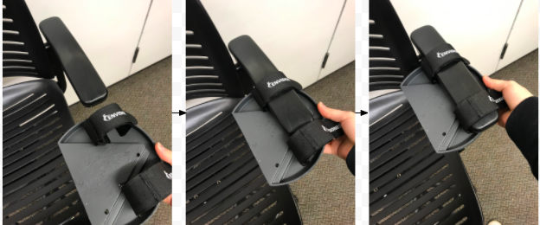

Figure 11: How the MiCO Should be Placed onto the Armrest

1. 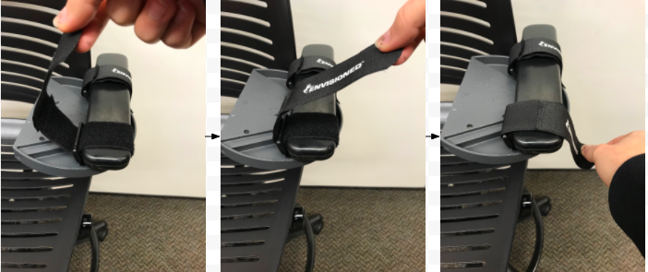Pull from the tab on the Velcro to adjust the size of the loop (see Figure 12). Resize it to fit the armrest tightly. It should be secure enough to prevent it from sliding down the armrest.

*Figure 12: Pulling the Velcro to Secure the Device onto the Armrest*

1. To open a container simply grab the desired jar or closed vessel by the base (not the lid) as demonstrated by Figure 13. This means the hand is farther down than the cap. Place the cap against the top part of the MiCO making sure that the edges of the cap are against the metal teeth on the V.

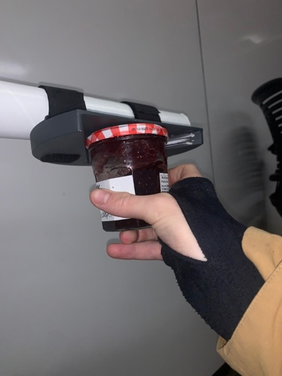

Figure 13: Bottom Side View of How the Cap should be Placed on the Device

1. Twist the hand clockwise about 45 to 90 degrees (see Figure 14). The objective is to loosen the cap, not remove it completely. This step does not require readjusting the hand position on the jar, just the movement of the wrist. Twisting should stop if the cap looks like it will fall.

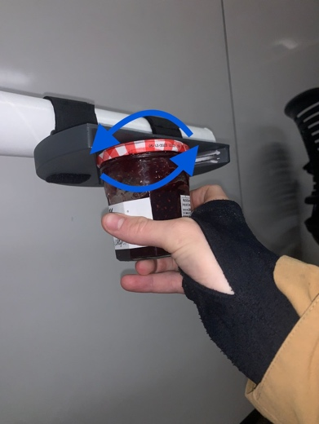

Figure 14: Movement with the Container once in the MiCO

1. Remove the container from the device and open with ease.
2. Enjoy the contents of the container.

# Limitations­­­­

At Northwestern, the quarter system moves fast, meaning that our group was limited in our ability to delve into our project in scope and depth. The primary constraint we faced was the limited time for research, design, and manufacturing— all to be done within ten weeks. Although we had adequate time for research and brainstorming, the design process had to be done relatively quickly. Additionally, this meant that we had little time to refine our prototype; in other words, our final design would be rudimentary and basic.

Outside of time, several other limiting factors contributed to our engineering design process. The Segal Design Institute at Northwestern had allotted $100 to each group for prototyping and manufacturing. Moreover, this also resulted in an increased awareness of the price of the solution if we were to bring it to market— we needed to design a cheaper product so that more people could potentially reap the benefits of our solution.

Another limitation we encountered was the access we had to the user. Because of the COVID-19 pandemic and HIPPA regulations, we could not engage directly with the user; rather, we had to communicate with the project partners, thereby inhibiting our ability to perform user testing with the actual user themselves. Any proxy testing, we conducted was less accurate, because our proxy users did not face the same day-to-day challenges as our user. Just having his feedback and having him try our prototypes would have been invaluable, but we had to make do without this resource.

# Conclusion

The MiCO (My Instant Container Opener) device is an affordable, effective, and discreet container-opening system that allows Igor, a person with paraplegia, to quickly and easily open containers of various dimensions from his wheelchair. MiCO’s unique attachment onto the wheelchair leverages the user’s full range of motions and upper body muscles, completely negating any worry about lack of either grip strength or fine motor skills. The blade technology allows for maximum points of contact with the container and creates more than enough friction to successfully loosen the lid of the container.

Additionally, the circular design of MiCO’s base, extended plastic barriers, and protective sleeve ensure that any user will not hurt themselves while using MiCO. The choice of materials for this solution—plastic, steel, and Velcro— makes cleaning easy and effective. Moreover, the Velcro straps and carrying sleeve help stow-away MiCO when its use is not needed, clearing the armrest for Igor to do anything he pleases.

The design is composed of three main components and an optional fourth:

* Plastic base: a circular disk that holds together the assembly of MiCO
* Metal blades: two pieces of metal, resembling saw blades, that provide friction when turning the container
* Velcro straps: adjustable straps that can secure MiCO onto the wheelchair tightly
* Protective sleeve (optional): a plastic cover that protects MiCO from miscellaneous dings and protects fingers and other objects from MiCO’s blades when stowed away

With MiCO, Igor and other people in wheelchairs do not need to worry about opening containers, allowing them to gain some of their independence and focus on living their lives.

# Directions for Future Development

This device had been designed for a particular user, for the specific model of wheelchair. However,

this product is adaptable to other circumstances, it can easily change sides on the arm rests

depending on preference and adjust to multiple sizes of armrests. We started with an existing product, the EZ JarOpener®, for the initial design (For specific technical instructions for the product refer to the Appendix E: Instructions for Construction and Bill of Materials); however, next steps would be to manufacture the base and blades from scratch, producing a new device specifically for people who use wheelchairs, rather than trying to augment an existing market solution.

In general, more performance testing is required in order to reach conclusions on the practically of

the existing solution and how our modifications enhance its performance. Specifically, some of

the questions we need to answer are as follows:

● Does the device, when used as intended, successfully assist in opening containers?

● Which secures onto the armrest more tightly: backpack straps or Velcro?

● Which is easier to use: backpack straps, Velcro or neither?

● Where is the ideal placement of the device? On the side of the armrest? In front of the

armrest? Underneath the armrest?

● How strong is the existing solution? Will it fracture easily?

● How dangerous are the metal blades, really?

● Are there any other modifications we can make, regarding inherent design, placement,

quality, or safety that will enhance the utility of our product?

These questions can all be answered through multiple methods of inquiry. More rigorous, in-depth

performance testing may be conducted on specific nuances of MiCO that our group did not have

a chance to cover due to limited time. Although we came up with a testing plan and assessment

form that we completed (see Appendix H: Performance Testing), a more formal assessment, developed with the help of an analytical agency or expert, may bring in more conclusive, or simply better, data.

# Appendix A: Project Definition

**Project Name:** Assistive Container Opener

**Client:** Shirley Ryan AbilityLab (SRAL)

**Team members:** Ahmad Alhayek,Isa Candal, Lainey Neild, and Nicholas Wolanske

**Date:** December 4, 2021

## Mission Statement

We aim to improve the ability of the user —a person with paraplegia in a wheelchair—to open containers with the use of only one arm.

## Project Deliverables

* Final Report
* Final Prototype and Design Representation
* Final Presentation

## Constraints

* Due Date: December 4th, 2021
* Budget: $100 allocated towards design and prototyping

## Users and Stakeholders

* The user, whom we shall refer to as Igor, will use the device to open containers independently
* Igor’s mother, who helps him open and close containers
* Ms. Randi Applehans and Ms. Meghan Griffin, the project partners, are occupational therapists who work with Igor to restore some habitual independence in his life

## User Profile

The user, whom we shall refer to as Igor, is an 18-year-old male recovering from spinal cord and nerve damage as a result of gunshot injuries. Paralyzed from the waist down, Igor is confined to his wheelchair. He also has little to no movement of his left arm and reduced functionality of his right arm. Some of Igor's physical limitations include difficulty opening and closing his left hand, no mobility of sensation in his legs, a limited amount of grip strength (10 lbs), and fine motor skills. However, Igor continues to have mobility and sensation on his left shoulder, elbow, and forearm and has control over his right hand, arm, and shoulder. He has no tremors or shaking and can press a lever or a button.

## Illustrative User Scenario

Igor lives with his mother who can assist in completing certain tasks. However, Igor wants more independence so our device will hopefully help him open containers and jars without help from anyone else. He spends his entire day in his wheelchair so our design should either be able to attach and detach from the wheelchair or be able to be freestanding and small enough he can slip it into his backpack for school.

Currently, to attempt opening a pill bottle, Igor secures the pill bottle between thigh and fingers on left hand. He grasps the top with a functioning right hand and presses against it while twisting with his right wrist. However, since his left hand has no functionality, this does not work, and he fails to open it. To attempt opening a jar of peanut butter, Igor makes use of his elbow crease by placing the jar between his left upper and lower arm. Then he presses against the top and twists right wrist, but it doesn’t work and just slips in his elbow. Unfortunately, Dycem does not solve this problem. Igor uses the Dycem® by placing it in the palm of left hand and pressing the jar against it. Then he tries to twist the top off with his right hand and wrist, but it still doesn’t give him enough traction and stability over the jar.

## ​Project Requirements

Table 1: Project Requirements Summary

|  |  |  |  |  |
| --- | --- | --- | --- | --- |
| Needs | Metrics | Units | Ideal value | Allowable value |
| Lightweight product [Can be lifted with one arm] | Weight | lbs | 0.5  [Moderately lightweight from experience, allows for the introduction of sturdy pieces] | 0.67  [Estimate of what would be the threshold for it to become heavy to the user] |
| Portable [Carried in wheelchair or backpack] | Volume | in3 | Less than 125 in3  [Doesn’t have to be a cube but a size accessible to the hand, the better fit in his hand the more grip he can have] | 125 in3  [If bigger, could result in becoming too heavy] |
| Subtle | Colors | - | Black/grey  [Sleek design with not much notability. Must not draw attention] | Colored metals  [Colors should be easy to control but if we do use different metals that are not dark and discrete for a better functionality it is allowable/] |
|  | Noise | db | 0-20  [Ideally the value would be 0 but there is some leniency for some noises to be made. The objective is to not call attention to the user.] | 40  [Sounds like a refrigeration, can bother but still doesn’t call too much attention [1]] |
| Durable | Time | years | 3  The product should last at least a couple of years. It needs to be sturdy and resistant to corrosion. | 1-2  [Because it is a product that is being tested, we have to allow ourselves some flexibility. If overall effectiveness of the product is affected by changes to better its durability, the effectiveness should be prioritized] |

# Appendix B: Research Appendix

## Primary Research: Project Partner Interview

### Methodology

On September 23rd, 2021, the team held a Zoom meeting with the project partners Meghan Griffin and Randi Applehans. They are both occupational therapists at Shirley Ryan AbilityLab that work closely with the user. The objective of this meeting was to get insight on our overall purpose and to clarify our existing questions. Several teams presented their questions and created a useful and informative discussion. Teams were given the chance to build up on other’s questions, encouraging a further level of understanding.

### Introduction and Project Partners

Randi and Meghan are employed at a day rehabilitation center where they help individuals who left a hospital to reintegrate into the community. They aid people with neurological impairments, either stroke, brain injury or spinal cord injury, on their path to regaining their independence in everyday tasks. These may include getting dressed, learning how to cook, or just being an active participant in a society.

### Overall Needs

The user needs a device which will facilitate the opening of various containers. The user lacks movement in his left arm and has limited hand grip in his right arm resulting in significant in opening containers independently. The device needs to be both versatile and relatively subtle.

### Current Solution

The user positions their upper arm in such a way as to stabilize the container against their body to open the container with their unaffected hand. The main issue with this technique is that there is no stability, and the container falls and remains unopened. Other methods the user has tried including using his upper arm and chest, which have mobility, to better secure the container, or also using his teeth for plastic that can rip easily. In addition, a material called Dycem® is used to stick containers to a surface to help in the process of opening them. However, it is not effective because it does not provide the stability that our user needs in order to apply the amount of force required to succeed at opening the container.

### User Information and Preferences

The user is an 18-year-old male who has a spinal cord injury. This was a consequence of a gunshot wound. Some of the user’s physical limitations include he is unable to open and close his left hand, his legs are paralyzed with no mobility or sensation, he does not have a large amount of grip strength (10 lbs), and fine motor skills present as a challenge. However, the user continues to have mobility and sensation on his left shoulder, elbow, and forearm and has control over his right hand, arm, and shoulder. He has no tremors or shaking and can press a lever or a button.

#### Living Arrangement

Regarding his living situation, he lives with his mother who can assist in completing certain tasks, but the objective is to help him navigate things on his own to help him regain his independence. The user is in a wheelchair with armrests (the specific model and design will be made available). He is also in high school and thus needs this device to be portable, compact, and minimalistic.

#### Container

The user desires a product which could open a variety of containers. The user wants the device to be applicable for grooming activities such as opening his toothpaste, which has a small cap, to cooking needs such as opening a jar of peanut butter in the kitchen. The product is not necessary for cardboard boxes or packages. Some of the most challenging containers to open for the user are peanut butter and jelly jars or medication bottles. Easy containers include plastic packages that are easy to rip with his teeth or containers with a push lid.

#### Additional Details

As previously stated, the user desires a product that addresses the challenge of opening different sized containers in a subtle fashion. The product needs to be reusable and accommodate his current living arrangement. Specifically, the user would want the design to be able to detach from the wheelchair and not impede any other functions. Additional constraints will be considered as more primary and secondary information comes to light.

#### Discussion

After reviewing the information obtained, we determined some key points to keep in mind during the design process. Due to the constraints regarding the user’s movement, fine motor skills, and the frequency he will be using this device, it must be light, efficient, and accessible. In terms of design and appearance, the device should be subtle and minimalist looking. However, the device must retain functionality by accommodating a wide variety of containers, ranging in size and shape from a toothpaste tube to a jar of peanut butter. We learned that it is possible to attach the product to the side of the user's wheelchair.

## ­­­­­­

## Primary Research: Proxy User Interview

### Methodology

On October 14th, 2021, the team held an initial call with a proxy user, Ms. Dorthy Brown, and her caretaker. Ms. Brown is a person who had a stroke which induced semi-paralysis on the left side of her body. Due to scheduling limitations, the call was shortened, and a follow up call was organized for Thursday, Oct 21, 2021.

### Introduction of Proxy User

Ms. Brown had a stroke on the left side of her brain at the age of 45 resulting in sever paralysis of the right side of her body. She spent three weeks in hospital, followed by months of rehabilitation and recovery. After her stroke, Ms. Brown had a partial recovering in mobility and arm / hand function, giving her greater independence in function. However, as she has grown older, Ms. Brown has begun to lose some of these functions, resulting in her currently living with a caretaker to see to her needs.

### Current Solution

Currently, Ms. Brown has limited ability to open any containers. Simple pill bottles, such as Aspirin, can be opened, but anything requiring significant grip strength requires another person to assist. Due to increasingly weak grip strength in her left hand and a complete lack of mobility in her right hand, Ms. Brown would struggle to open a container even if it was held in place. Thus, Ms. Brown currently relies extensively on other individuals when trying to open containers.

### Previous Solutions

Ms. Brown previously used the EZ Off Jar Opener® in her kitchen to open containers. She sighted this device as being assistive in opening containers although she can no longer use it due to decreased grip strength. Additionally, Ms. Brown acknowledged the cup holder in her car as a great means of stabilizing a container. She was able to open water bottles, and other containers with her left hand by stabilizing it in the cupholder.

## Secondary Research Summary

### Overview

The user: our user, whom we will refer to as Igor, is an 18-year-old male who is a casualty of a gunshot, which left him paralyzed from the waist down and with little hand and arm function, especially in his left arm.

### Anatomy and Kinesiology

#### Mechanics of the Hand and Arm

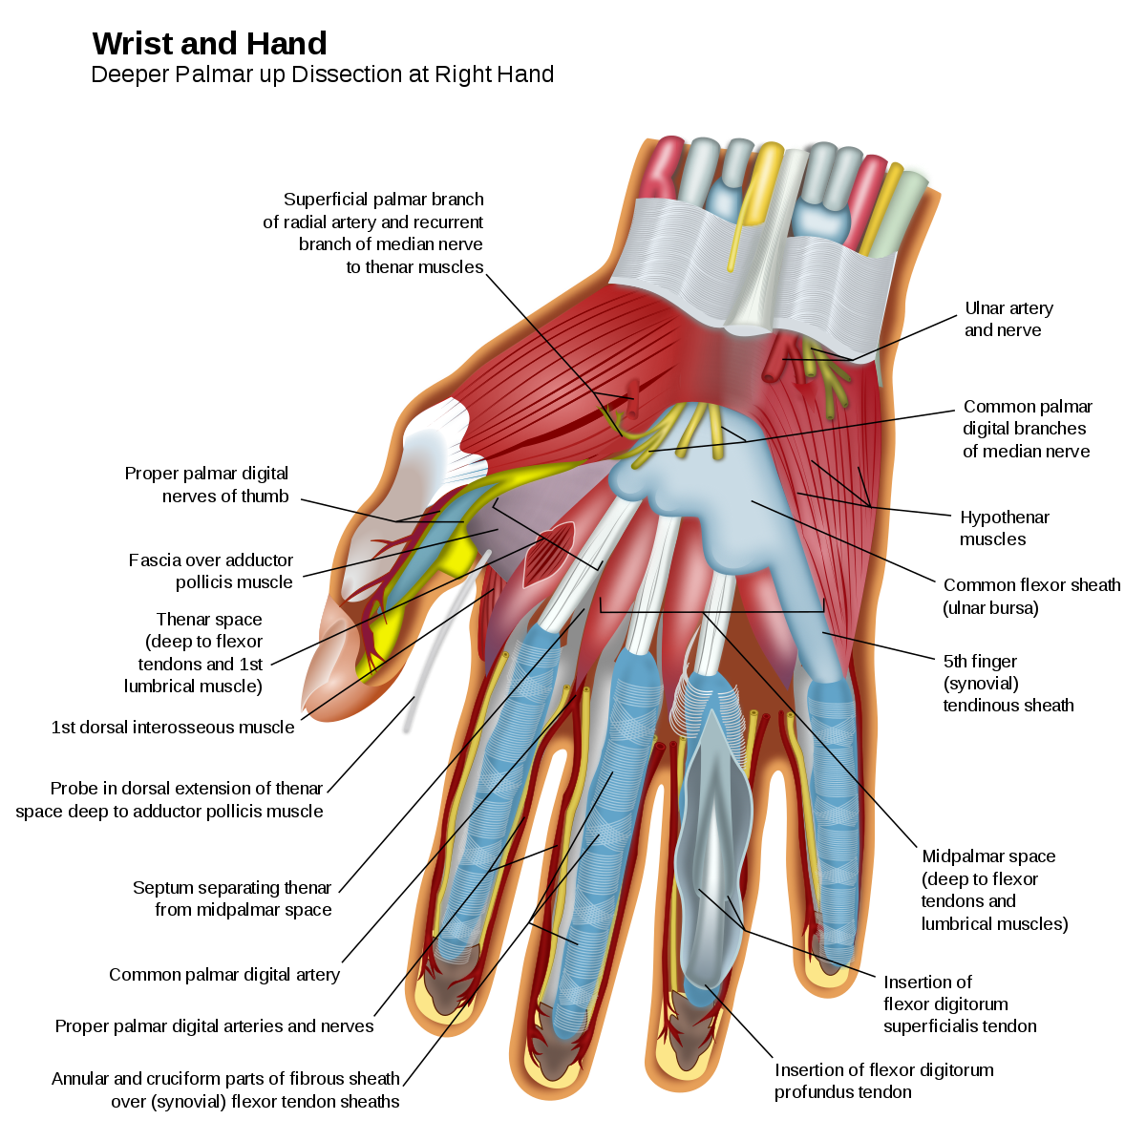The interossei (palmar and dorsal) muscles occupy the space between the bones of the hand [B1]. Dorsal interossei allow the fingers to spread away from each other, and palmar interossei pull the fingers together. The hypothenar muscle group forms the bulk of the pinky-finger side of the hand. These muscles allow for independent movement of the pinky finger, cupping of hands, and bending of the fingers at the joints. Thenar muscles consist of the area around the thumb (see Figure 15 for muscles of the hand). The opponens pollicis allow the hand to grasp, which is one of the most important functions of the human hand. Lumbrical muscles allow the fingers to bend and straighten. Forearm movement occurs when the radius wraps around the ulna. Guided by tissue in the elbow and joints, this contributes to upper extremity mobility. In some motions, forces at the elbow can exceed several times the entire body weight [B2]. The shoulder is composed of a “chain” of 18 muscles, which act in synergy [B3]. Interactions between the radius, ulna, shoulder, and hand create motion, stability and force interactions that allow for the function of the arm.

Figure 15: A View of Hand Anatomy [B2]

#### Grips and Grip Strength

Males today have an average of 99 and 101 lbs of grip strength in their right and left hands, respectively [B4]. Grip strength increases exponentially from childhood to adulthood, and wanes in elderly age. Physical and occupational therapists measure grip strength to assess hand functionality and recovery. Grip strength also varies depending on the position of the arm. A 90-degree flexion of the elbow, as opposed to fully extended, corresponds to higher grip strength [B5]. Osteoarthritis, a common rheumatic disease associated with damage of cartilage and bone, has been widely studied and associated with decreases in grip strength and ability to perform manual activities. The Mayo Clinic notes that gripping a device, such as a toothbrush, with larger handles may make doing that activity easier [B6]. Moreover, a study in chimpanzees found that power grips were more effective with a larger object (which in this study was a grape) [B7].

#### Types of Grips

Development of motor skills through childhood into adulthood can be characterized by utilization of different types of grips. Children most frequently manipulate objects with fisted and palmer grips, which use early fine motor skills and require motion of the whole arm [B5]. As children age, motor skills develop, and gripping/grasping techniques become more refined (see Figure 16). These types of grasps require minimal elbow and shoulder movement, and primary control comes from the wrist and fingers.

Figure 16: Illustrating Different Types of Grips in Children and Toddlers [B5]

There are two main types of grips: power grasp and precision grasp [B1]. In the power grasp, the adductor pollicis stabilizes an object against the palm with a stationary hand. Cylindrical, 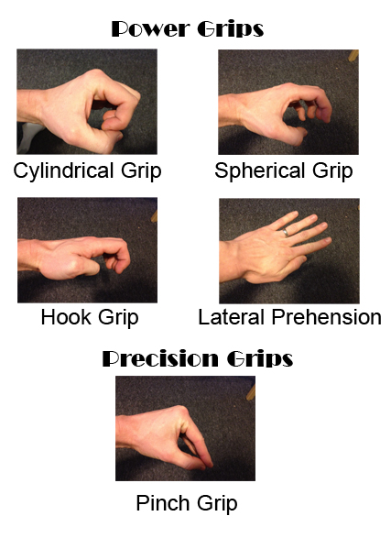spherical, and hook grips fall under the umbrella of the power grasp (see Figure 17). In the precision grip, the hand is dynamic. Muscles are active that abduct or oppose the thumb. Precision grips include tripod, tip-to-tip, and lateral prehension.

#### Overcoming Limitations to Movement

Arthritis, which is inflammation of the joints, hinders movement and rotations. According to the CDC, 54 million Americans, or about 1 in every 4 adults, suffer from arthritis [B8]. Occupational therapists and doctors have developed techniques to aid those with arthritis in opening and closing jars. Some of the techniques are as follows:

Figure 17: A View of Power and Precision Grips [B1]

* Holding the jar closer to the individual’s body utilizes other, larger muscles
* Wearing rubber gloves allows for more resistance between the hand and the surface, increasing grip strength
* Wrapping the jar in a towel or washcloth keeps the hand from slipping and provides additional grip
* Using smaller containers allows for a smaller surface area to hand ratio, which makes them easier to open
* Training grip strength with a handheld device or physical therapy.

#### Conclusion

When designing a product intended to assist people with limited hand and arm mobility, the design team must consider the amount of grip strength the user has. A device that requires more grip strength than the user possesses is rendered useless. Moreover, the angle and position of the device must be considered, to maximize use of torque, gravity, and other muscles.

### Stroke and related injuries

#### Injuries Frequently Resulting in Monoplegia

Several various injuries and conditions cause monoplegia, paralysis in one arm. Monoplegia is often interlinked with hemiplegia, weakness of one entire side of the body [B10].

#### Background on Stroke

Stroke remains the leading cause of monoplegia and hemiplegia [B10]. A stroke happens when an interruption occurs to the blood supply of the brain. Brain cells do not receive the oxygen or nutrients they require and die off, potentially resulting in paralysis and loss of motor function. Strokes are generally classified in two forms, ischemic and hemorrhagic; ischemic strokes are caused by a blockage in a blood vessel supplying the brain while hemorrhagic strokes occur when there is bleeding into the brain [B10]. Most strokes— 87%—are ischemic, with a significant portion of them— roughly one in three— of unknown cause, as seen Figure 18. Due to the varying nature of strokes, in both type and location, one cannot generalize the effects of a stroke on a person [B10].

Figure 18: An Informative Infographic Relating to Stroke [B9]

#### Effects of Stroke

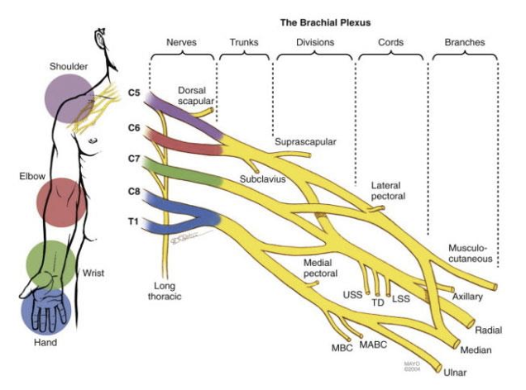Second to stroke in frequency, trauma to the brachial plexus is another leading cause of monoplegia [B11]. The brachial plexus is a series of nerves that extend from the spinal cord down to the shoulder, arm, and hand (see Figure 19). When damaged, individuals could experience arm paralysis, lack of muscle control or a lack of sensation in the arm, hand, or wrist [B11]. Like stroke, there is a wide spectrum of injury involving the brachial plexus. Avulsion, the most severe type of injury, occurs when the nerve is ripped or cut from the spinal cord. On the opposite side of the spectrum is neuropraxia, a stretch injury, in which the protective covering of the nerve is damaged, yet the nerve itself may still be fully functional [B12].

Figure 19: A View of the Nerves Extending into the Arm [B11]

Although injury to the brachial plexus can occur through a multitude of accidents, missile injuries (bullet wounds) are the second most common cause of brachial plexus injuries [B12]. Missile wounds cause nerve damage as the body experiences shock waves, cavitation, and sometimes a direct impact to the nerve cords [B13] [B14].

### Existing Solutions

#### Dycem Non-Slip Self®, Adhesive Material

This design, shown in Figure 20, is essentially sticky material that someone can wrap around their arm and use to stabilize the jar opening process. You can hold the jar’s lid against this sticky material on your arm and use your other hand to turn. It is an effective design, but the drawback is you add another whole step of applying the wrap to your arm. Then, after you open the jar, you must take the wrap off. Additionally, if there was a liquid inside of the jar, it might spill due to the unusual angle. [B15]

Figure 20: Dycem Non-Slip Self ®[1] [B15]

#### Dycem Non-Slip Cone-Shaped Bottle Opener®

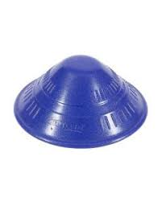This design, shown in Figure 21, is one of the better ones on the market. It is small, portable, and non-battery operated. You can store it in your kitchen or take it with you when you travel. The only significant drawback is it is not that efficient. It works by creating a better grip on the jar’s lid. You apply it directly over the lid and then twist, but there is nothing to stabilize the jar, so the user is still compelled to stick the jar between their legs or under their arm for use. [B16] It merely serves to make the opening a little bit easier, but it is nowhere near as effective as the built-in at-home devices. Additionally, if the user does not have control of their legs, it is practically useless. [B17]

Figure 21: Dycem Non-Slip Cone® [B16]

#### Under Cabinet Jar Lid & Bottle Opener

This product, shown in Figure 22, is a container opener that is fastened under a cabinet or container. This solution is arguably the closest solution to what would work for our user. In this design, the user can open multiple sized containers. Additionally, only one functioning arm and hand is required to use this whereas most of the other solutions require two functioning hands. Additionally, this solution is subtle (installed under a tabletop), does not require a battery, and is reusable. The only drawback is that it is not mobile. So, if the user wanted to open a container out at a restaurant, or at school, or in any environment that is not his house, he could not. [B17]

Figure 22: Under the Cabinet Jar Opener [3]

#### Jar Key Container Opener

The design of this solution, as seen in Figure 23, was originally intended with people who have some functionality in both arms and hands but just limited hand strength, for example, a user with. So, this solution would not work for our user. However, it has components that our team might want to incorporate into the design. This design is the smallest and most lightweight. It would be perfect to slip into a backpack and take anywhere. Additionally, it is reusable and does not require any type of motor [B17].

Figure 23: Jar Key Container Opener [B17]

#### Automatic Jar Opener

This jar opener, see figure 24, looks like a spaceship as it is cumbersome and bulky. It will take up a great deal of space in our user's kitchen cupboard and will not be convenient to carry in his backpack. Additionally, it requires a power source, such as batteries. While the mechanism is effective, its drawbacks in terms of size and power-source are considerable. Moreover, it only works for a finite number of container sizes and is loud when in use. It is also more expensive than any of the other solutions. So, although this solution only requires one functioning arm and hand, it is more expensive, more noisy, less versatile, and heavier [B18].

Figure 24: Automatic Jar Opener [2] [B18]

### Materials

When investigating on the possible materials, we decided to consider various compounds. It was a broad look that will help us narrow down the multiple options and combinations. For this process we had to keep some ideas present so that we didn’t deviate from the original purpose. Materials should serve in favor of the product, which means they must be complacent with some main characteristics. For example, the product should be easily portable. This means it must be lightweight while still being strong and sturdy enough to apply force to it. It will also be used in different environments, like the bathroom and the kitchen, so it should be easily cleanable and disinfected. Furthermore, durability is also a factor to consider. One time use materials like cardboard, or thin plastic should be explored in order to be improved upon or considered a last resort due to economic restrictions as cost is another important variable in this project.

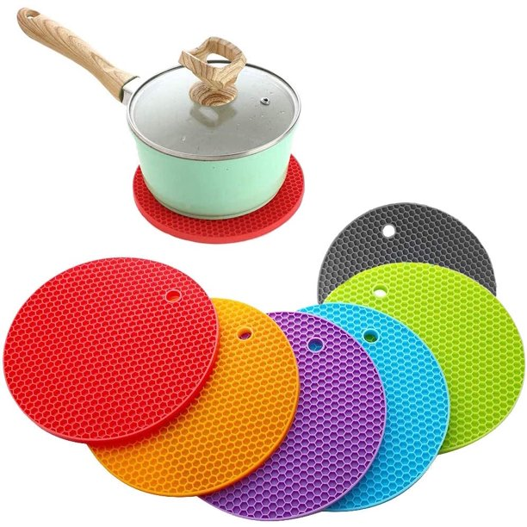In addition, grip strength is an important characteristic to consider when it comes to choosing materials. There are several ideas to consider within this category like the physical manipulation of the material. For instance, the addition of ridges or crevices, or the lengths and angles that can be determined to optimize the grip strength. The material could also contribute its own adhesive or non-slip properties. Silicone is a good material for this reason. It already exists as a solution to prevent slipping, but we would need to modify it to fit our needs [B19].

Figure 25: Round Silicone Trivets, Pamolon, Round Silicone Trivets, model: YQ-1250 [B19]

In Figure 25, we notice that the silicone contributes to the non-slip properties of silicon while also incorporating textural differences to increase the overall grip strength.

A study for the “Grip strength changes in relation to different body postures, elbow and forearm positions”, conducted in 2013, showed that changes in the position of one’s hand can impact the amount of grip strength used to conduct everyday tasks [B20]. A conclusion that we can take into consideration was that one produces more grip strength when the elbow is extended. Simple changes like this in the behavior of the patient could potentially be beneficial to the effectiveness of the product by increasing the ultimate output of strength. This means that we can produce a product that uses materials and shapes that optimize human performance in the area of need.

#### General Possible Materials

* Aluminum: Compared to other metals it is lighter. Its alloys produce stronger compounds. [B21] It is insensitive to cold work, which means it requires heat and molds in order to achieve desired shapes. This means that it needs the appropriate tools which demand training and higher costs. Small pieces bought in the correct shape could be utilized.
* PVC: Otherwise known as Polyvinyl Chloride [B22]. It is a hard, durable material that is sold in multiple sizes. Regarding costs, it lies on the cheaper side and might be a good material to make mockups. Easily moldable with heat. It is lightweight and sturdy. It is also easy to clean.
* Wood: Compared to other materials it lacks the strength and ability to be cleaned. It would require the reapplication of oils in order to maintain its durability and is ultimately not the best material for this purpose.
* Silicone: Non-slip properties. “Silicone rubber compounds were easy to process, require no expensive equipment and have adjustable working times and cure rates” [B23]. It is accessible to us and easily moldable.
* Non-slip coatings: a spray that adheres to given surfaces in order to make them more graspable to the person or to the container [B24]. Commercial uses for these are mostly for floors and streets to prevent people from slipping but could be applied in the product in specific regions to increase the grip strength of that area.

#### Conclusion on Materials

It is important to consider efficiency and effectiveness when it comes down to selecting appropriate materials. Combinations of different materials can increase both properties. Selecting silicone, for instance, paired with PVC or aluminum could yield a sturdier and highly graspable product than them on their own. We could also introduce other material combinations that contribute other physical properties, for instance, magnets. Clasps could also be used to attach the device to the container to aid in gripping it. There are endless combinations of materials that could improve the overall design, but in this case, it is important to keep in mind the costs and benefits that every material has. As stated previously, the material is there to serve a purpose to achieve the end goal. While aesthetics is important to consider, they are not the main priority if the device is portable and functional.

### Team Discussion

After gathering this information, we understand the importance and relevance of fully comprehending the situation with secondary sources. It was important to analyze the problem from different angles, from medical to more technical, in order to gain a wider perspective on the problem and the possible solutions. We can now further understand the limitations of hand paralysis and reduced grip strength, the impact of damage to the brachial nexus, and existing solutions that could help us develop our own ideas. It is key to keep these ideas present during every stage, to reflect and rely on previously gathered sources to substantiate our ideas. This secondary research creates a base for us to use our creativity at its fullest while being grounded and on topic.

# Appendix C: User Observation

## Observation 1: Videos of the User Opening Containers

### User Observation Summary

Ahmad Alhayek, Isa Candal, Nicholas Wolanske, and Lainey Neild observed footage taken by occupational therapists (OTs) Randi Applehans and Meghan Griffin at Shirley Ryan AbilityLab (SRAL) in the first week of October 2021. The purpose of this recorded footage was to understand how the user maneuvers around in his wheelchair, uses his arms, and opens jars and other containers. These videos last a cumulative 79 seconds. This appendix details the methodology used to conduct the observation, describes the user’s current mobilities and limitations, and summarizes the results of the observation.

### Methodology

This observation took place remotely, but the videos were filmed at Shirley Ryan AbilityLab in Chicago, Illinois. Meghan and Randi also sent answers to questions we had via email.

### Information about the User and His Wheelchair

The user, whom we shall refer to as Igor, is an 18-year-old male recovering from spinal cord and nerve damage as a result of gunshot injuries. Paralyzed from the waist down, Igor is confined to his wheelchair. He also has little to no movement of his left arm (only being able to move his shoulder) and reduced functionality of his right arm. Thus, Igor has difficulty opening jars, cans, containers, pill bottles, etc.

The wheelchair is the model Shoprider XLR 14 PowerTilt Power Chair.

The characteristics of the wheelchair pertaining specifically to opening containers include:

* The armrests are independent from the front: something can be slipped in if necessary.
* Dimensions of wheelchair arm: length: 17.7”, width: 4”
* The distance between the top of the wheelchair arm and the user's lap when sitting in the wheelchair is 7”
* It had a footrest, which could be useful for support
* There is storage space in the back. It is not large, but it could accommodate a discreetly sized product

### User’s Interactions and Difficulties Opening Containers

#### Process of Opening a Pill Bottle

1. Secures pill bottle between thigh and fingers on left hand
2. Grasps top with functioning right hand
3. Presses against top and twists right wrist; does not work
4. Changes position to press bottle against left palm and twist; does not work
5. User fails to open pill bottle

#### Process of Opening a Jar of Peanut Butter with Elbow

1. Places jar between left upper and lower arms (in elbow crease)
2. Presses against top and twists right wrist
3. User fails to open the jar

Table 2: User Observations without Dycem: Opportunities, Follow-up, Suggestions

|  |  |  |
| --- | --- | --- |
| Observations | Opportunities | Follow-up |
| User has difficulty getting container in a fixed position - attempts to secure it between legs, bended left arm, with left hand | Find a way to keep container and / or lid fixed in place | Consider designs to keep either the container or lid fixed in place for the user |
| Grasps top of containers with right hand, | Investigate if the grip used is optimal for opening containers | Consider grip alternative when grasping top, possibility of using a glove |
| Attempts to open lid, containers slip due to no secure grip on bottom half | By holding the container and / or lid in place, the user should be able to open the container | Combining the two ideas outlined above, a sturdy grip + fixed container / lid would allow the user to open the container |

#### Process of Opening a Jar of Peanut Butter with an Existing Solution, Dycem

1. Places Dycem® (sticky material; shaped like ribbon (approximately 5 cm wide and 30 cm long)) in palm of left hand
2. Pushes bottom of jar against Dycem
3. Twists top with right hand and wrist
4. User fails to open the jar

Table 3: User Observations with Dycem: Opportunities, Follow-up, Suggestions

|  |  |  |
| --- | --- | --- |
| Observations | Opportunities | Follow-up |
| User has difficulty attaching Dycem® between the container and left hand | Similar as previous table: find a way to keep container and / or lid fixed in place | Consider why Dycem® isn’t sticking. How can our design avoid the same problem? |
| Grasps top of containers with right hand, palm grip on lid (abduction of hand) | Find a way to improve grip strength on lid of jar | As mentioned before, consider grip alternatives, glove, and other adhesive material |
| Attempts to open lid, containers slip less due to Dycem, however not firm enough grip to open container | The Dycem® solution almost worked. Improving how the jar is held down would allow for the user to successfully turn the lid. | Our group should consider if trying to improve the Dycem® is a good design route. Can we use the existing product in some way or design one that is better? |

### Discussion

From these videos we can understand in a better way the difficulties in the process of opening containers and the position of the user with regards to the wheelchair. We need to find a way to help in a way that the existing solutions he is using aren’t. The Dycem® on its own is not effective but it may be employed or integrated into another product to increase its effectiveness. We could also see that the user has space around his armrest and could move comfortably between the arm rests. There are opportunities to explore different ideas after completing these observations because they will help keep us grounded and realistic about the possible products.

# Appendix D: Mockup Appendix with User Feedback

## Methodology

We recorded short videos in the Ford Engineering Building at Northwestern University of our mockups in use with detailed descriptions, narrations, and questions for the occupational therapists, and forwarded them to Meghan and Randi at Shirley-Ryan AbilityLab in Chicago, Il. They responded to our videos in further correspondence via email and provided comments (relayed in quotes) and answers to our questions. Meghan and Randi also included pros and cons lists for each concept.

## Mockups

### Criss Cross Container De Coupler

* 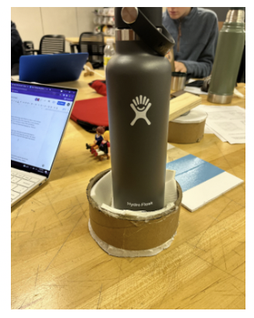Concept: This idea combines two identical conical shaped parts to open a container. One part is a base to secure the container, and the other is coated in sticky or friction-inducing material to create friction and force to help open the lid (see Figures 26 and 27).

Figure 26: A Front View of De Coupler

* Rationale: This concept serves as a simple way to open different containers. As shown in Figure 3, the conical shape of the base and top fit containers of varying radii, which helps the user to open anything from toothpaste to pill bottles. Furthermore, the concept allows the user to operate it with only one hand, since the base will attach to the wheelchair armrest via suction cups. This device meets the portability requirement because it is also compact and can be stowed away, instead of remaining permanently attached to the wheelchair.

.

#### Feedback

* Pros / Cons

Figure 27: A View Inside De Coupler

* + Pros: portability of the solution, wide range of varying containers that it can open, and a unique design
  + Cons: the mockup was large, and they wondered where the user would store the parts for easy access.
  + Design the solution to fit within the size of the wheelchair armrest
* Can the user grip the ratcheting part with his palm?
  + “He would probably be able to grip the ratcheting part. It may need to be a little smaller to allow a tight grip but should be fine if he doesn’t need to apply much pressure.
* Is he able to work more of his upper body muscles into the movement?
  + “Yes he can work more of his right upper arm muscles into the movement. The user wouldn’t like to keep both sides attached during the day since it would be in the way of carrying things in his lap/using his hands/bending forward. He would only attach it when he needs to open something. Attaching it to one arm rest would be better.”

### Rocking Ratchet Wrench

* Concept: this design employs two parts: a sticky base, Figure 28, and an attaching ratchet, Figure 29, to help open the container, like the previous design. The conical structure of the attaching part of the ratchet provides a strong frictional force and again, a tolerance for radii of varying sizes.
* 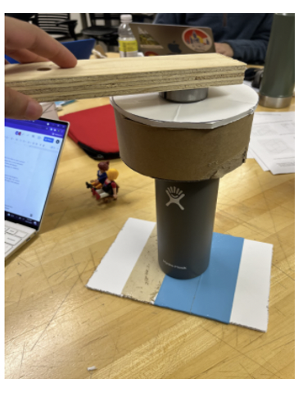Rationale: this solution meets the needs of the design by attaching firmly to all sizes of containers and being a one-handed motion. The ergonomic handle allows the user to grasp the device comfortably and leverage the length of the lever arm for more torque. This solution also enables the user to put more of their upper body muscles into the motions, since it is more of a push rather than an exercise in fine motor skills. Moreover, the user has total control of the motion and can adjust the force he gives and with what speed.

Figure 28: The Stick base

#### Feedback

Figure 29: The Ratchet Wrench

* Pros / Cons
  + Pros: Meghan and Randi did not leave any pros.
  + Cons: “I think the user could open the jar with just the grip surface on the bottom. The handle looks heavy so he may just prefer to use his hand to open it if the base was keeping the jar/container still.”
* We did not ask them any questions in regard to this design concept.

### Zip Time Cup Holder

* Concept: The Zip Time Cup Holder attaches to the arm of the wheelchair and uses adjustable grip zip ties to secure the container in the cupholder.

Figure 30: The Zip Tie Cup Holder Without Contents

* 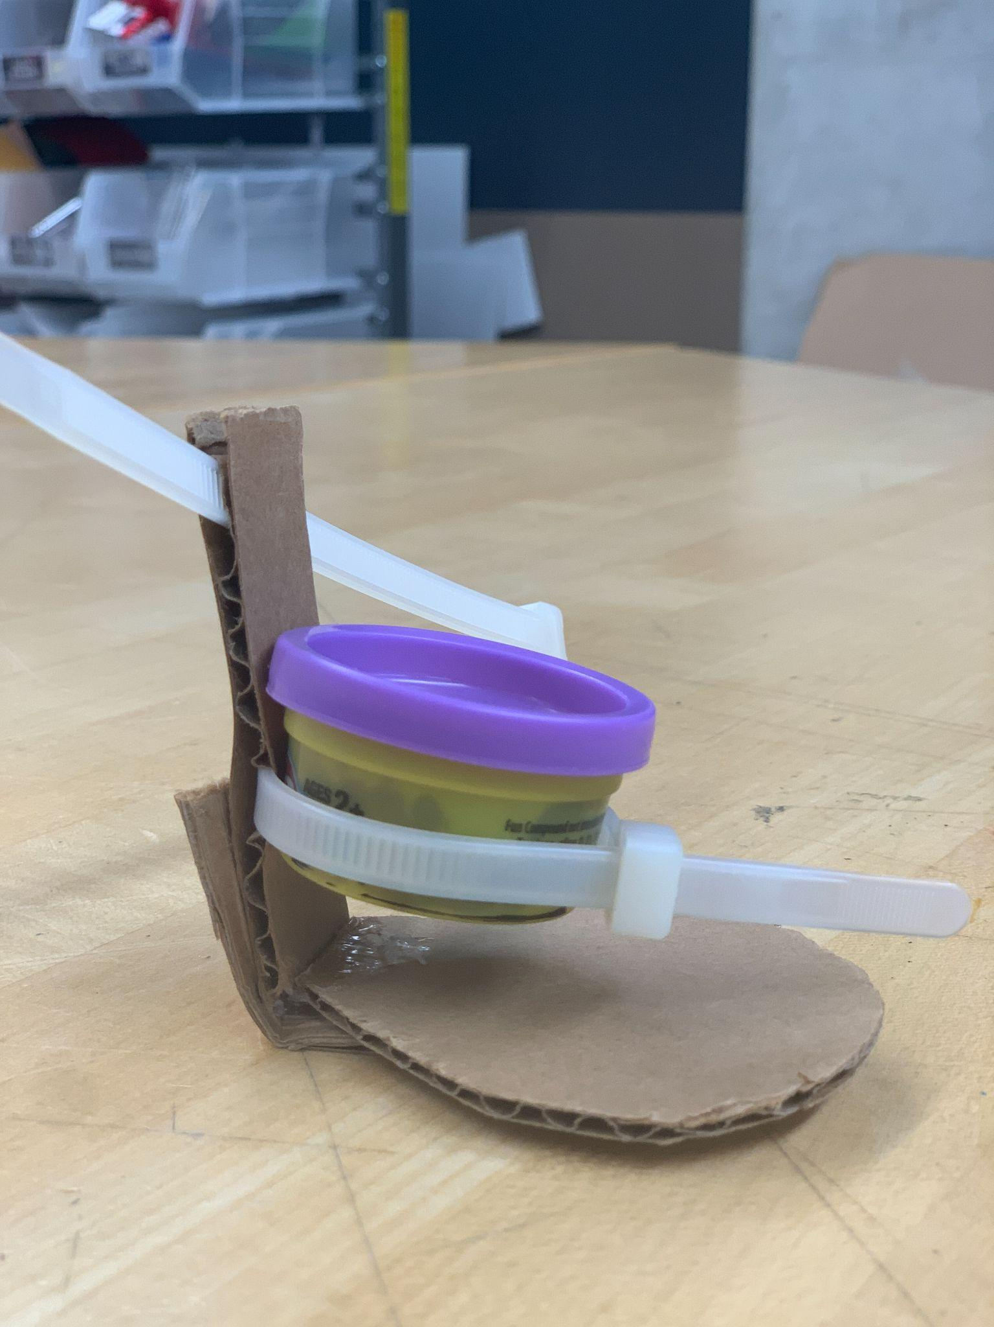Rationale: The zip ties serve to secure containers in an easy and simple fashion while also accounting for the versatile sizes one could encounter. The multipurpose nature of the device allows for the user to use the device as a water bottle holder or for any other container, while still meeting the design needs. Figure 30 display the device without any container in place (the back zip tie or another clamping mechanism would be used to anchor the cup holder to his wheelchair). Figures 31 illustrates how a container could be placed within the device and tightened to allow the user to remove the lid of the specified container.

.

#### Feedback

* Unfortunately, Megan and Randi were not able to look at this design and as a result, we did not get any feedback from them.

Figure 31: The Zip Tie Cup Holder in Use

### Rubber Clamp Cup Holder

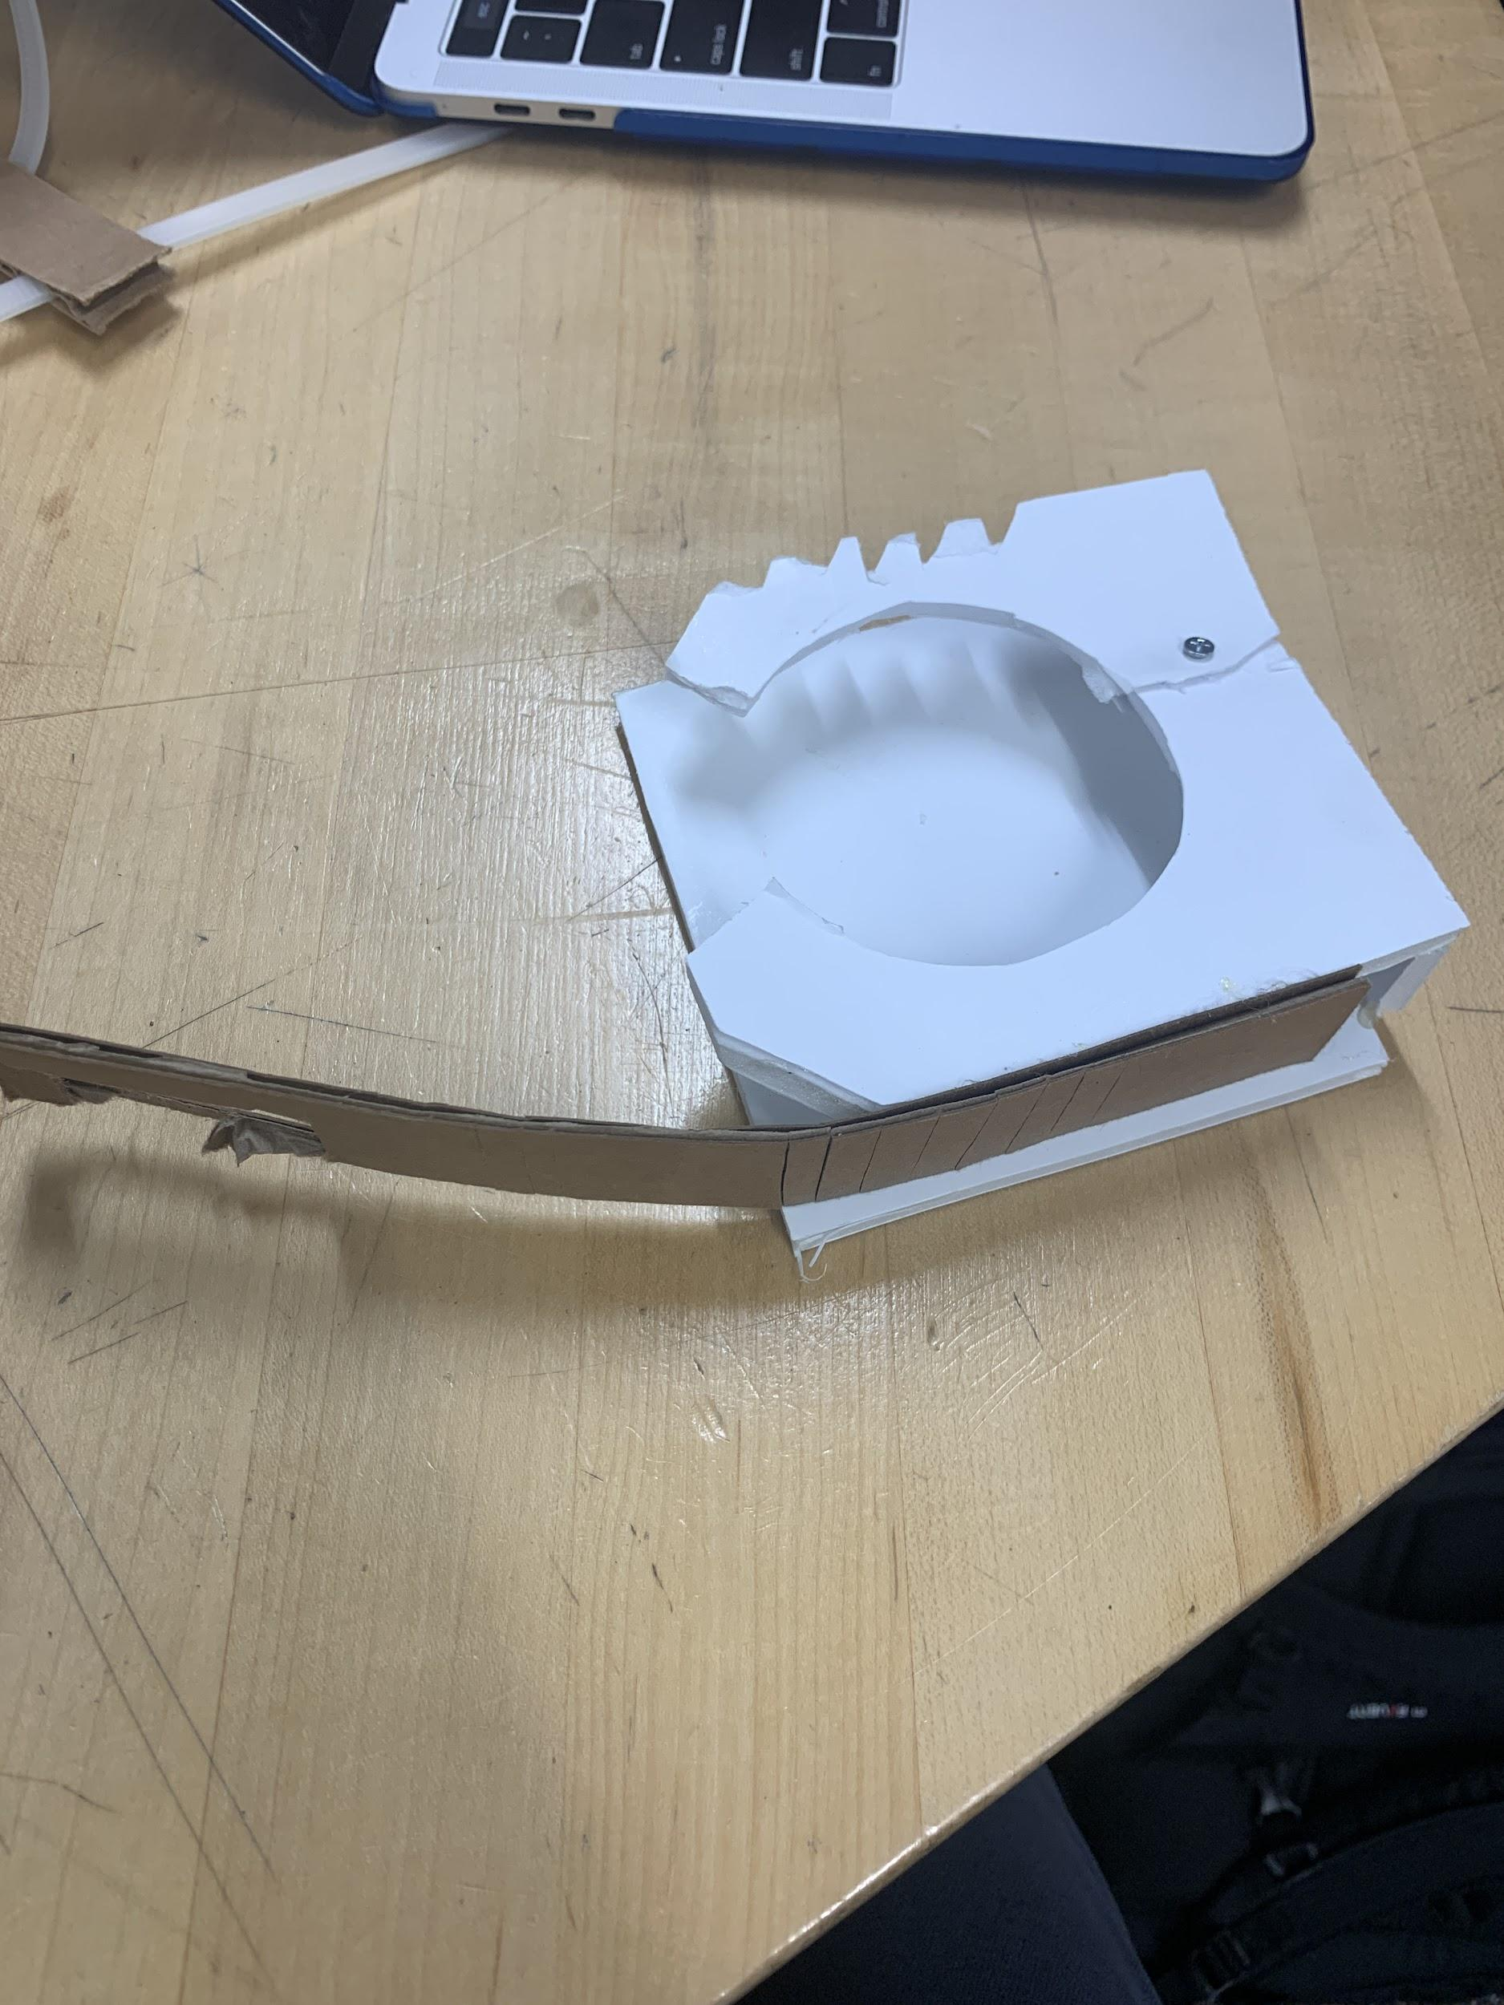

* Concept: Attaches to the arm of the wheelchair and uses adjustable rubber clamp to secure the container in place.
* Rationale: The rubber clamp serves in a similar fashion to the zip-tie to secure containers in an easy and simple fashion while also accounting for the versatile sizes one could encounter (see Figure 32). Once again, the device can serve both as a container holder for the user to open containers with and as a simple cup holder (see Figures 33). The main difference between the two designs comes in the locking / gripping mechanism. The zip tie allows for a more versatile container size while the rubber clamp has a stronger gripping mechanism and possibly be easier to latch as well.

Figure 32: A View of the Rubber Clamp Opened

#### Feedback:

* 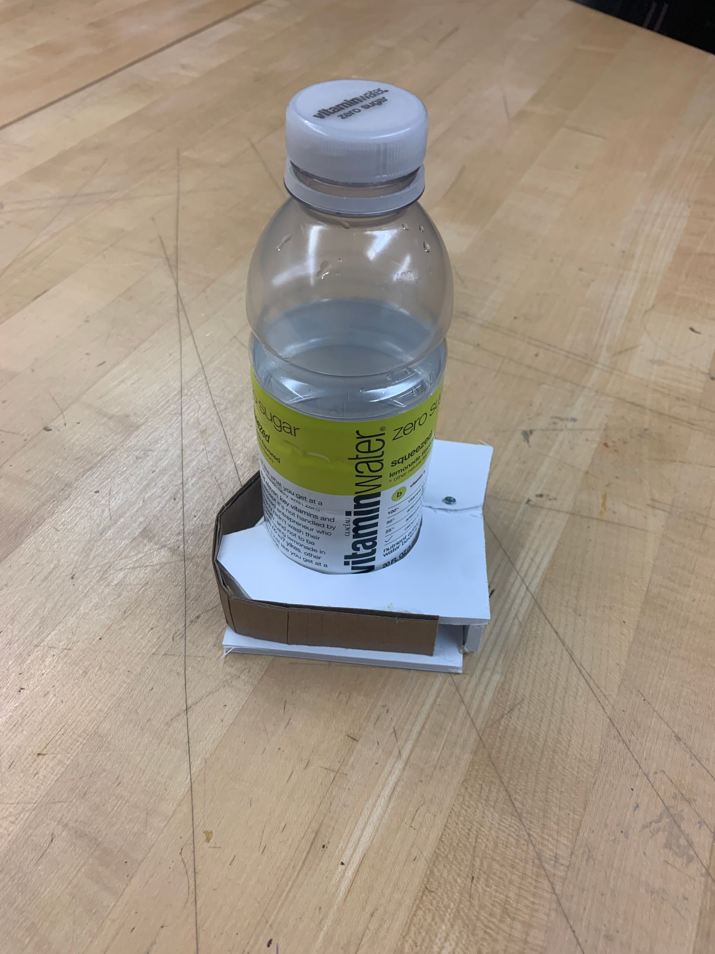Does the user have the fine motor skills for an adjustable strap?

Figure 33: A View of a Container Gripped by the Clamp

* + The project partner responded that he did have such skills to hook a strap but were concerned that the video showed the person utilizing two hands with the device rather than just one.
* Would the user be able to use a Velcro strap more effectively than a rubber one?
  + When asked if a Velcro strap might be an easier mechanism for the user, the project partners responded in favor of Velcro, but recommended having a hook on the end.
* Does the user already have a cup holder or other holding device on his wheelchair?
  + Not answered.
* If the device held a container firmly in place (i.e., pill bottle, peanut butter jar), would the user be able to unscrew the lid?
  + Not answered.

### The Air Pressure Device

* Concept: This device uses air pressure (see Figures 34 and 35) to secure a container for the user to be able to grip the top and twist or pop it off. The pressure would make the container sturdy enough to be able to grip it better, (see Figures 36 and 37) without damaging the container itself.
* Rational: This device would adapt to different sizes and provide support in the process of opening containers. This device would meet the requirement of being small and portable and very easily operated since it would be automated for the user. It is versatile and efficient, while being discrete.

Figure 34: A Top View of the Air Pressure Device

#### Feedback

* 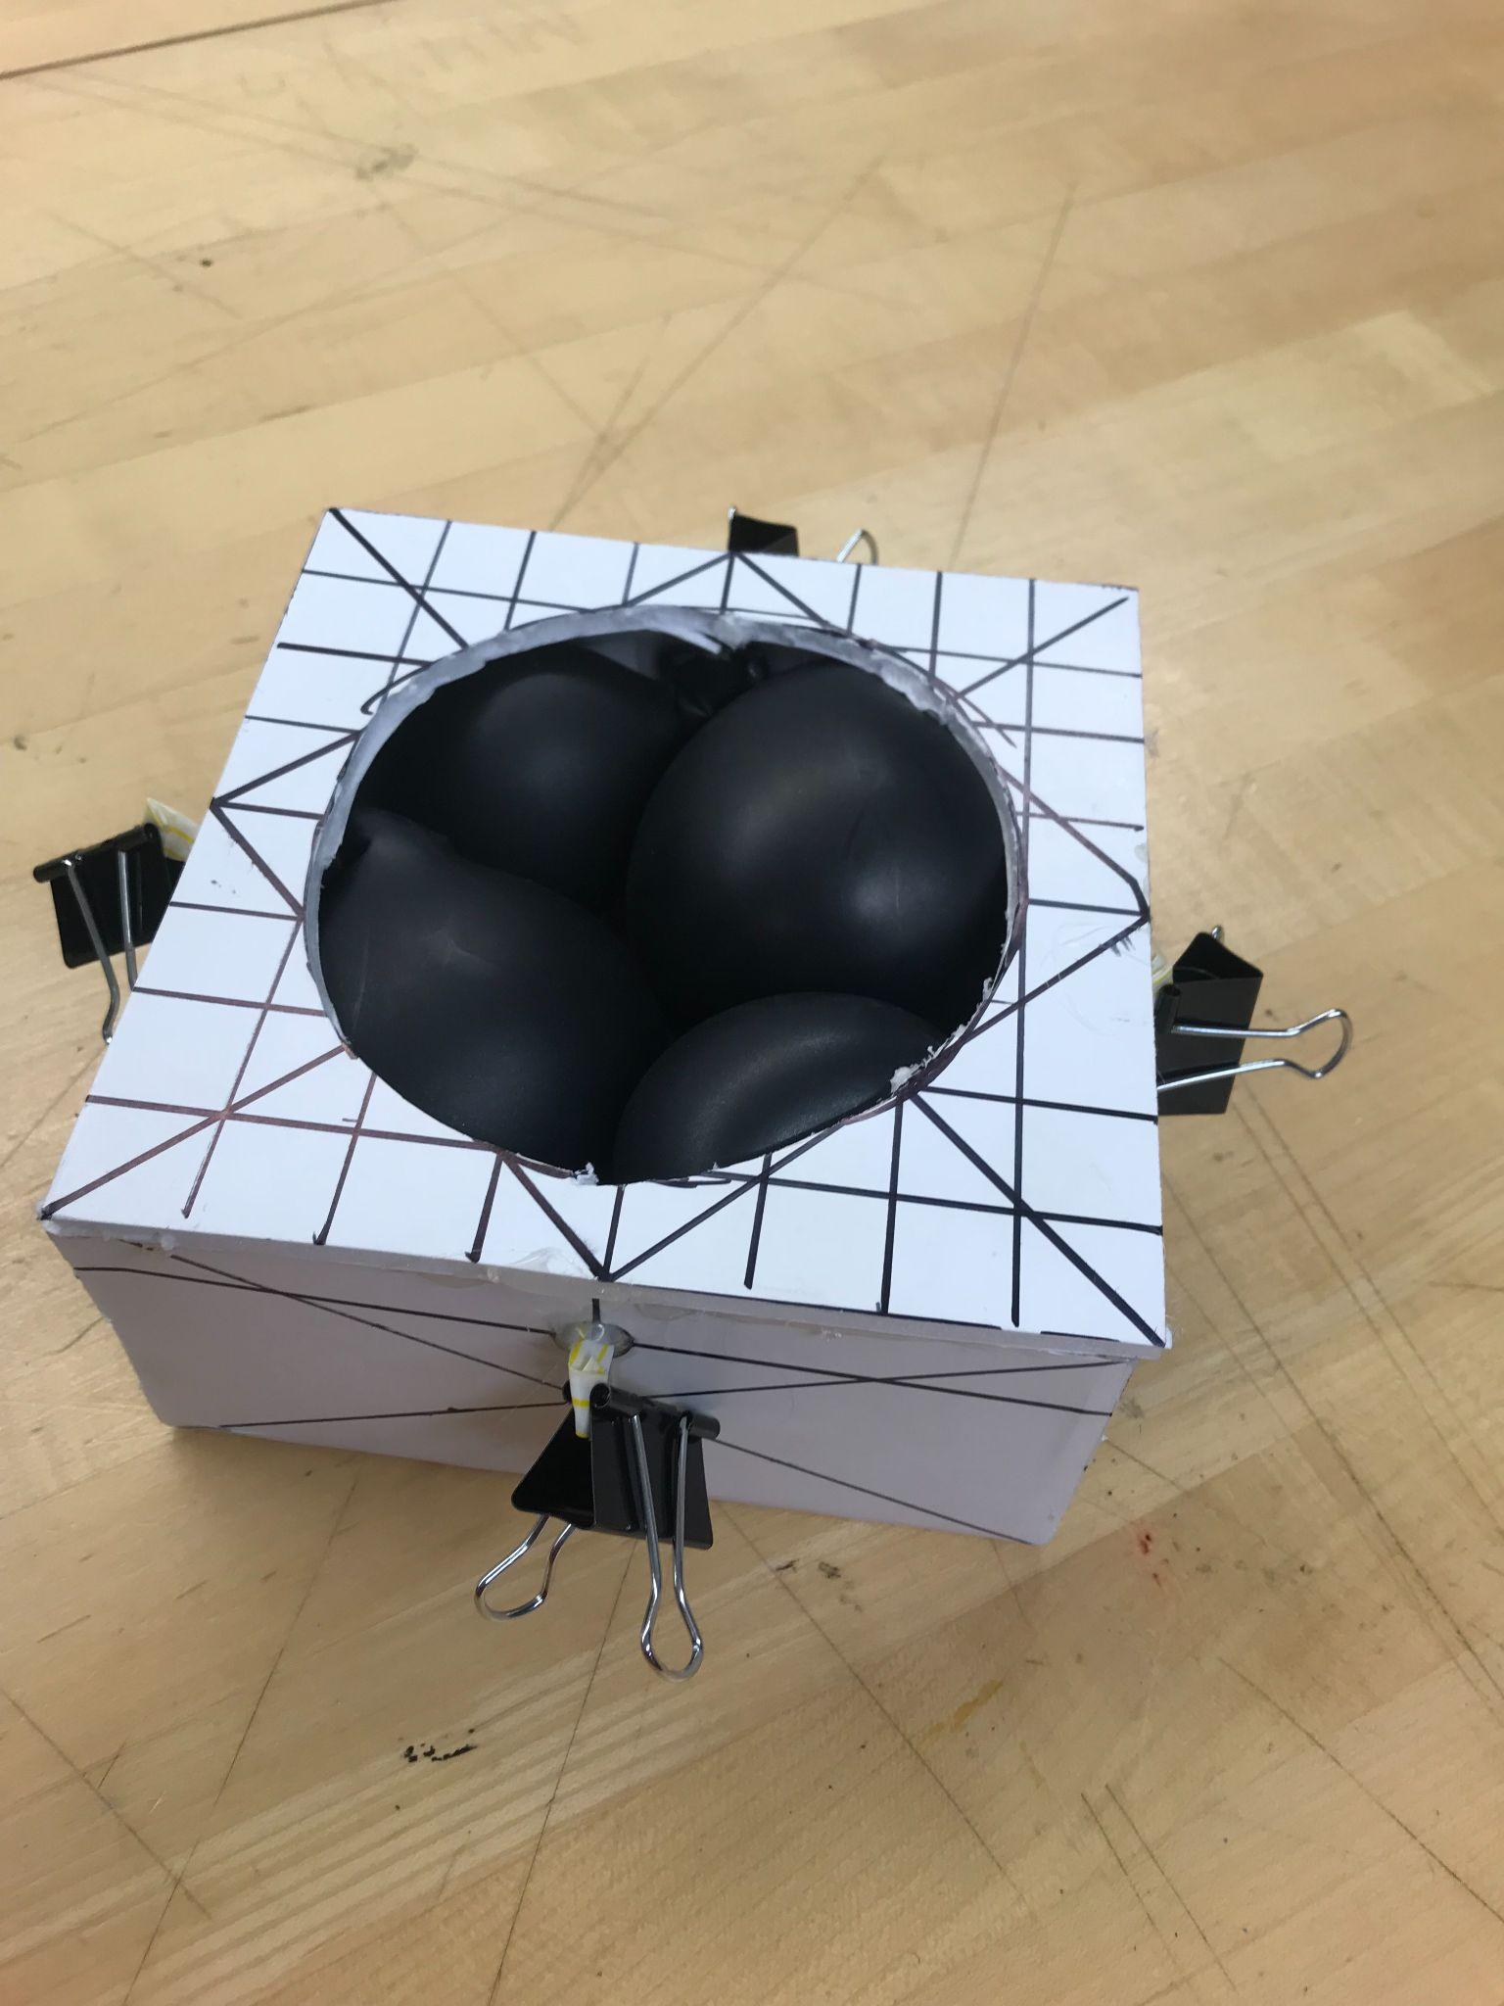Pros / Cons
  + “Pros: this is a cool idea! Would it adjust automatically to the size of the container”
  + “Cons: might be hard to push the item into the small space with 1 hand”
* Regarding the size and weight of the mockup: What does the user believe to be an ideal size?
  + “Ideal size: doesn’t go outside of the width of the arm rests otherwise the user can’t fit through doorways. Yes, he can lift all those household items, roughly anything under 10 pounds.”

Figure 35: A Side View of the Air Pressure Device

* Could the user lift a couple common household items like: a tissue box, a bottle of ketchup, or a water bottle, in order to determine an approximate ideal weight for the product?
  + “A milk jug is about the max he can lift.”
* Would the user be able to attach the bottom of the product to the wheelchair with Velcro with one hand?
  + “Velcro with one hand could be tough, maybe if the bottom of the box was sticky/could grip onto the arm rest without sliding off then he could probably do the Velcro.”

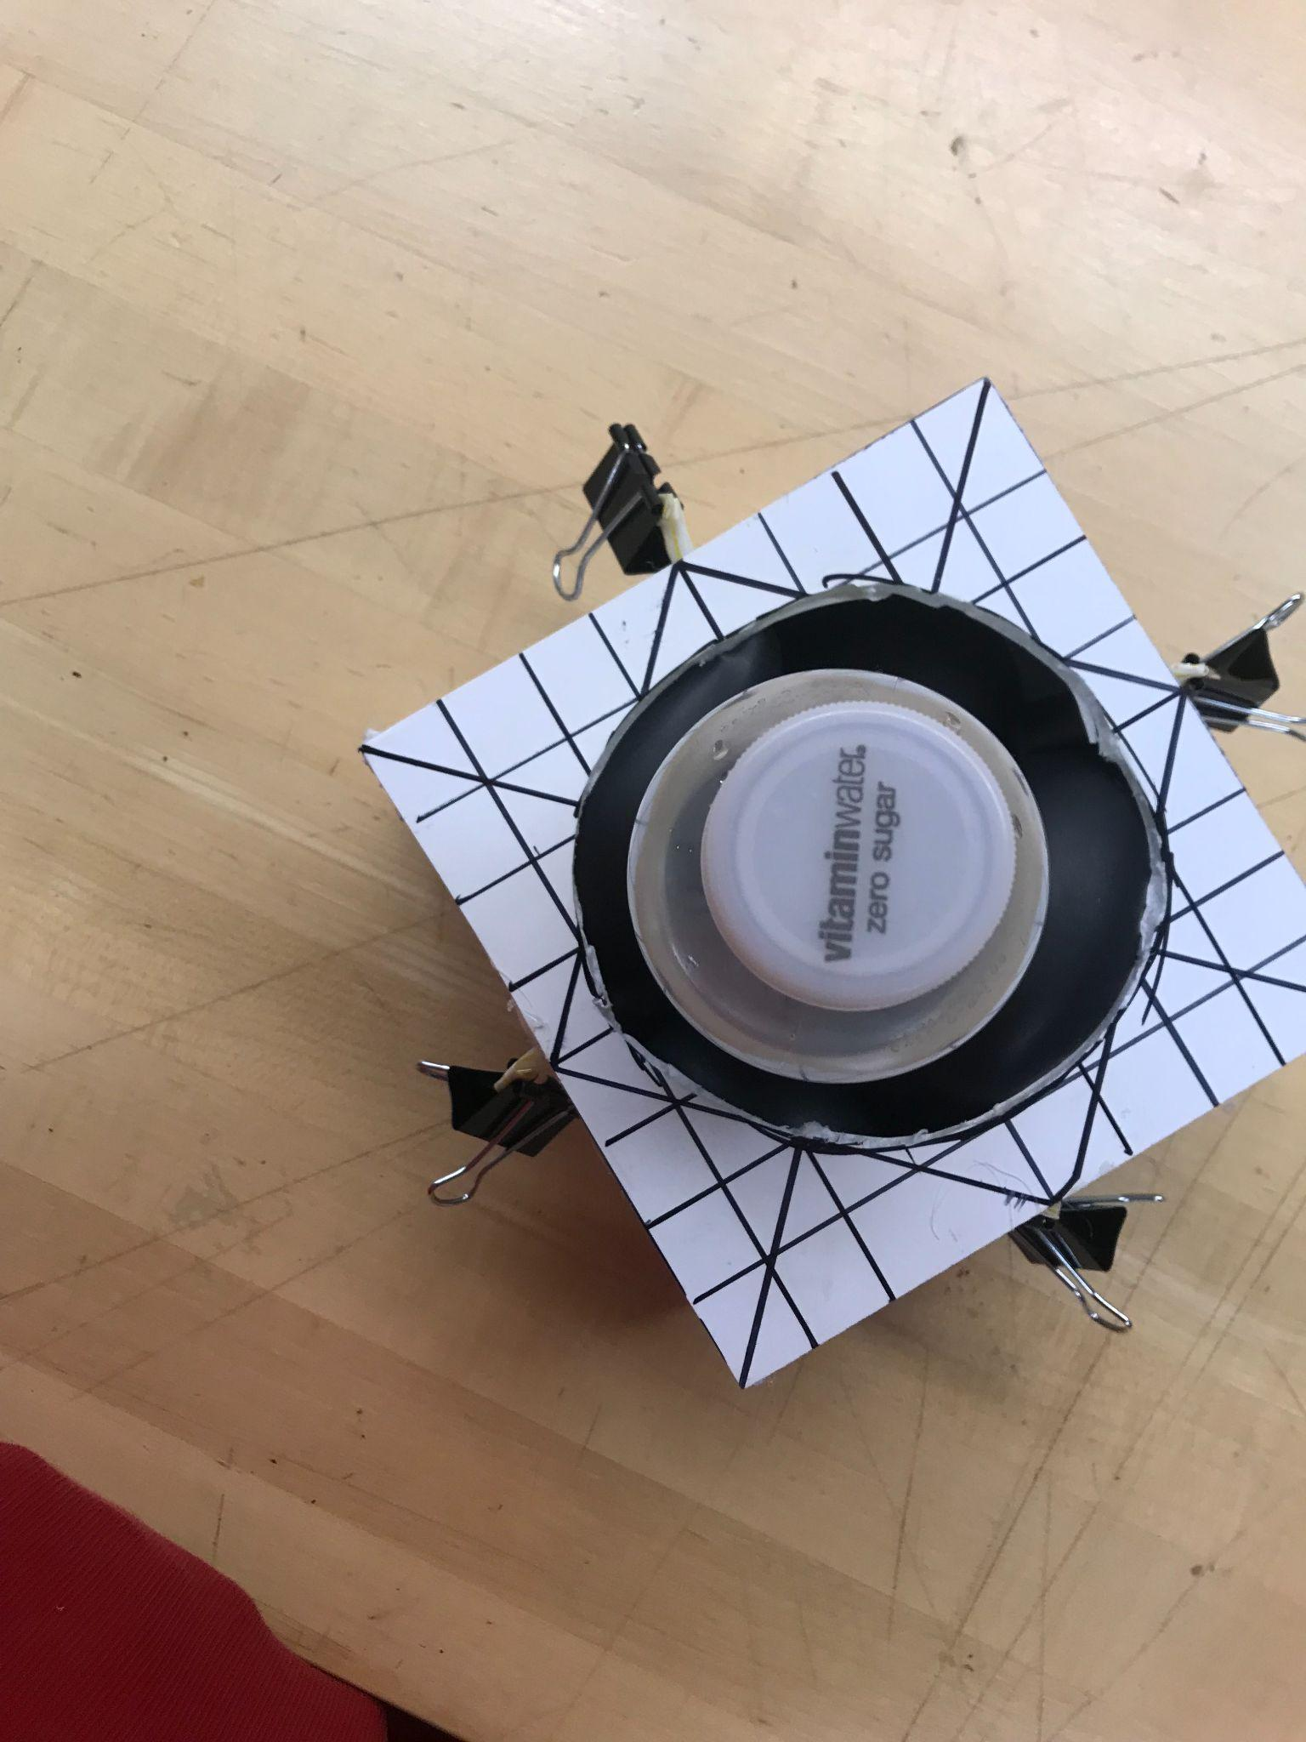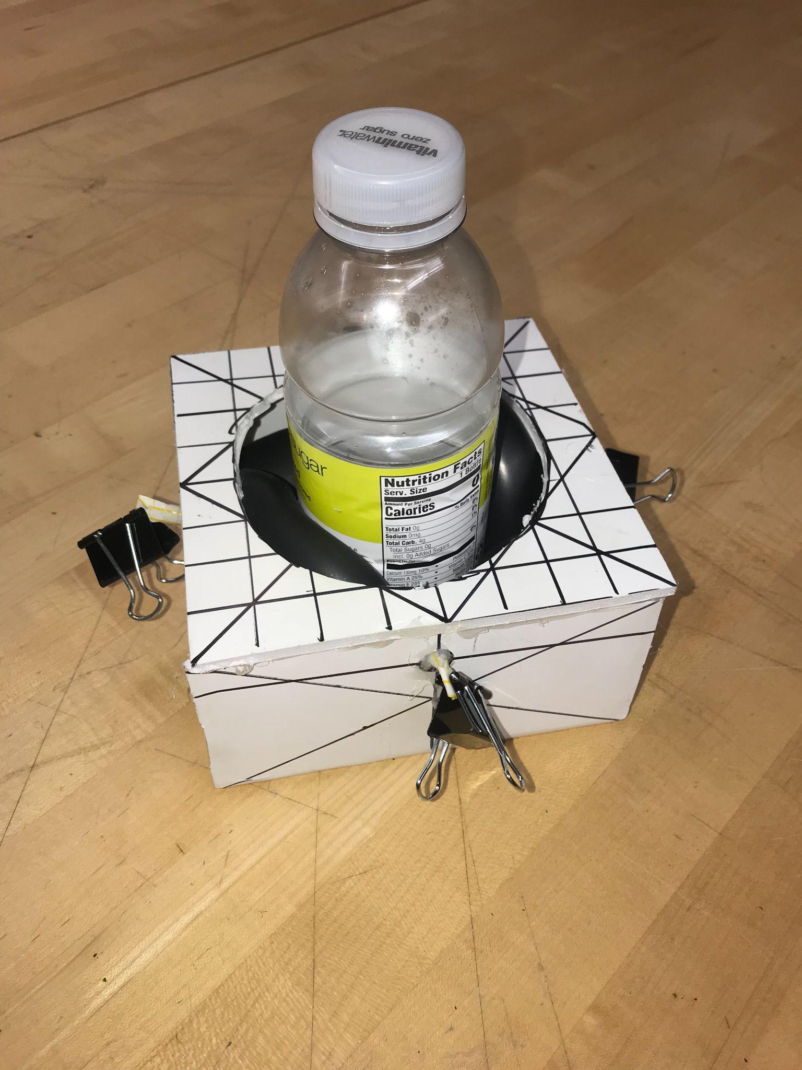

Figure 36: A Side View of the Air Pressure Device with a Container

Figure 37: A Top View of the Air Pressure Device with a Container

### The Clasp and Lock

* Concept: It comes in two parts. There is an attachment to the lid of the container and an attachment to the hand (see Figure 38). It works like the lock and key model, where the hand latches onto the clasp and twists to open the container (see Figures 39 and 40).
* Rational: It works for multiple sizes of containers because it is only an attachment to the caps of the containers, and the grip is solved by clasping onto the attachment. It's easy to access and small in size. It is discrete and easy to clean.

Figure 38: An Angled View of the Clasp and Lock

#### Feedback

* What motions is the user more comfortable with: pushing, pulling?
  + “It’s difficult to tell in the video but it seems like this requires decent strength in both arms?”
  + “He can push and pull with the right arm, but not with the left arm.”
* Is there any preference in size of the handle? Could we model the hand to make it comfortable specifically for the user?
  + “No size preference for handles.”
* Would the user prefer to attach a clasp to containers or for there to be a universal cap attachment for many different containers?
  + “Universal clasp seems like a lot of work to attach to all containers he’s trying to open.”

Figure 39: The Clasp and Lock Engaged

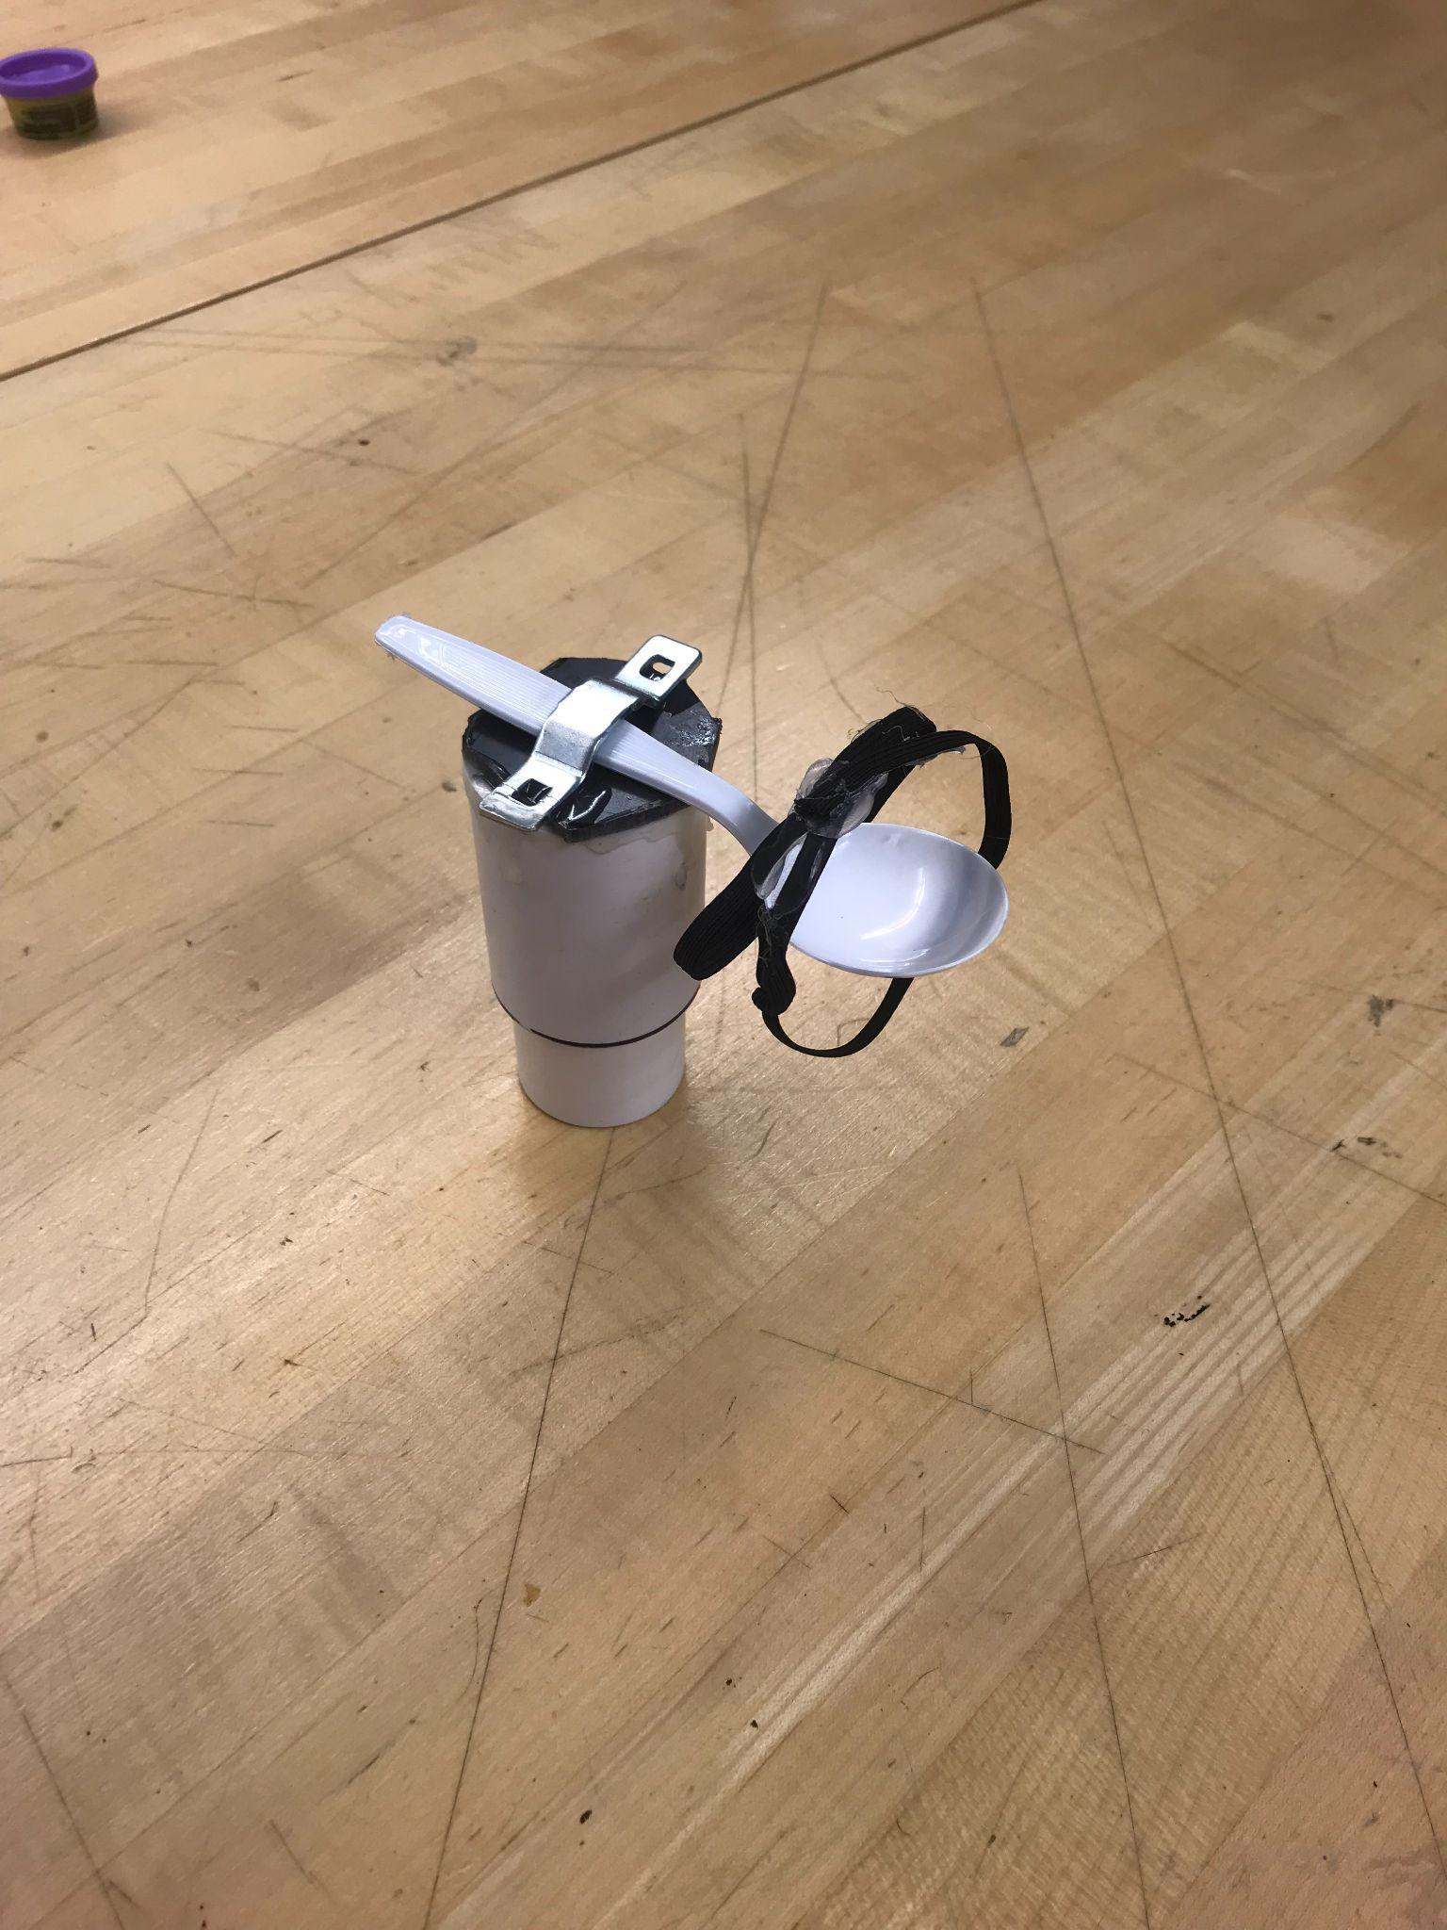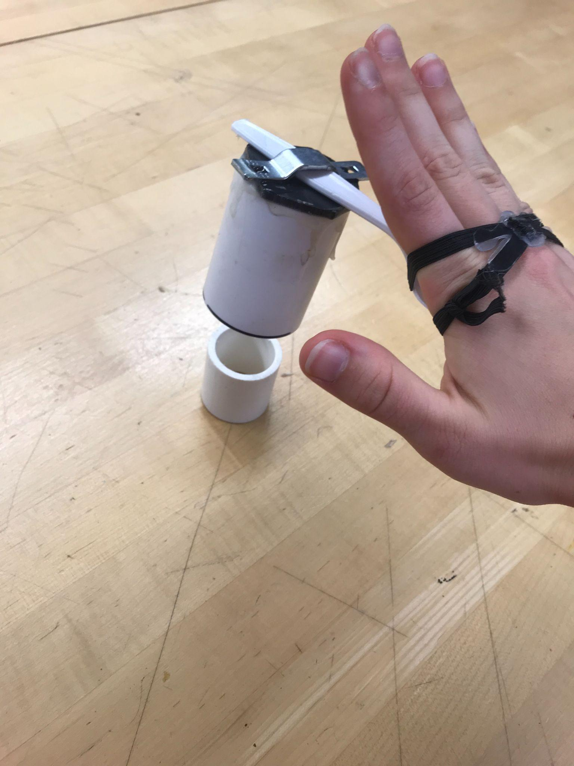

Figure 40: The Clasp and Lock in Resting Position

### The Tablelike Opener

* Concept: This device, seen in Figure 41, acts as a table to help stabilize a variety of containers. It attaches to the user's arm rests so it does not need to rest on our user’s lap as shown in Figure 42. The top of the table is covered in double sided sticky tape to help grip the base of any container.

Figure 41: A Top View of the Tablelike Opener

* 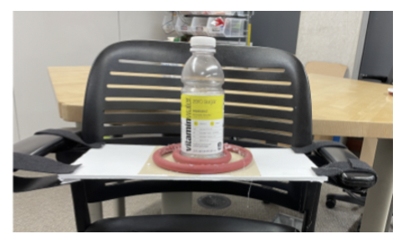Rationale: The user can rest the container on top and use his functioning hand to untwist the lid. None of the contents of the container will be spilled and it accommodates various sized containers as shown in Figure 43.

#### Feedback

Figure 42: A Side View of the Tablelike Opener Engaged

* Pros / Cons
  + Pros: “looks easy to open with 1 hand”
  + Cons: “large, the tray could be in the way, and he would have to remove and replace it more frequently.”
* Is this motion comfortable for the user?
  + “Yes, it looks like a comfortable motion.”
* Is the size of this device too ideal or should our team try to make it more minimalistic?
  + “Probably should be more minimalistic or collapsible.”
* Does the user have trouble taking this device out of their bag?
  + “He is able to access his backpack by grabbing it off the back of the wheelchair, I’m not sure if this device would fit in the backpack though.”
* Does the user like or dislike the idea to attach this design to both of the arm rests? Would the user prefer if it was attached to just one arm rest?
  + Not answered

### The Underarm Rest Jar Opener

Figure 43: A Front View of the Underarm Rest Jar Opener

* Concept: This device, seen in Figure 43, helps to grip the lid of any size container to help unscrew it. It attaches underneath the user's arm rests with Velcro as shown in Figures 44 and 45.
* Rationale: It has a V shape opening device that applies tension to the lid as shown in Figure 43. This way the lid accommodates any size of a top. The user simply puts the lid to where it fits snuggly and twists the bottle to get the lid to untwist, seen in Figure 45.

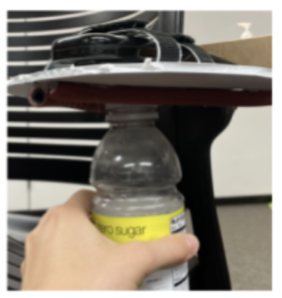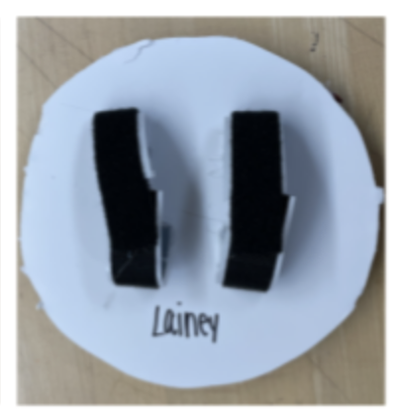

Figure 44: The Underarm Rest Jar Opener Engaged

#### Feedback

Figure 45: A Top View of the Underarm Rest Jar Opener

* Pros: “nice that it is easily attachable to arm rest and able to remove if needed”
* Cons: “might be awkward to reach around the armrest to access this and apply pressure upwards towards the arm rest to use it, but it could work!”

## Iteration

While reviewing the feedback from Meghan and Randi, we realized that a practical, functional solution would incorporate the values of compactness, accessibility, and minimalistic. We found that if there is an attachment to the arm of the wheelchair it must be facing up. Reaching under the arm rest is an awkward motion that we should avoid, because the user must manage to fit his arm, legs, and container within the tiny space spanned by the armrest and wheelchair. Moreover, we want the user to have a full view of the motion, and the user could potentially lose the lid, too, if it falls. The user could access the region above the arm rest more readily and therefore we must prioritize the mockups that consider this. Main concerns regarded the potential weight of the product and the independence that it could bring to the user. Some tasks like using Velcro to attach a possible device to a chair require two hands to set in place as it is a hard one-handed operation. This decreases the amount of independence that the user has and therefore should be avoided. The product should be easily attachable and graspable, which means no Velcro.

## Discussion

After deliberation, our group decided on two final concepts. Our deliberation first eliminated the solutions that we thought to be bulky or that resulted in awkward motions. The “Tablelike Opener” was eliminated due to its large size and position in the user’s lap, and the “Rocking Ratchet Wrench” was removed due to the bulkiness and impracticality of the handle. Moreover, we put aside the solutions that would be conducive for two-handed motion, which we know the user cannot do. That eliminated the “Clasp and Lock” and “Zip Time Cup Holder” solutions. The “Rubber Clamp Cup Holder” was eliminated simply because we believed our other solutions were superior. That leaves us with two plausible solutions: one is the Container Opener with Air Pressure (COWAP) device, which combines the “Criss Cross Container DeCoupler” and the “Air Pressure Device.” The COWAP builds on an existing blood pressure sphygmomanometer (pump) to provide adequate air pressure to secure the container in a base, and the ratcheting conical top can provide extra torque and friction to open a vast set of container sizes. The second solution has been coined “My Instant Container Opener,” which is a modification of the “Underarm Jar Opener.” This device will attach opposite the user’s dominant arm to provide more leverage and more natural movements. Further performance testing is necessary for this solution in order to determine its practicality.

# Appendix E: Instructions for Construction and Bill of Materials

Table 4: Materials Used for Construction

|  |  |  |
| --- | --- | --- |
| Material | Specifications | Quantity |
| EZ Off Jar Opener | 7.2” x 7.2” x 0.7” | 1 |
| Velcro Strap | 1” x 30” | 1 |
| Sewing Thread | 1’ Black Thread | 1 |
| Spray Paint | Matte Black | 1 |
| Plywood | 8” x 8” x ½” | 1 |

Note: See Bill of Materials in report for detail on cost and part numbers.

The following tools are required to construct this device:

* Vertical band saw
* Table saw
* Sewing needle
* Manual Mill and Clamping Set
* Chisel (or another prying device)
* Pencil
* Ruler
* Vertical belt sander (optional)
* Sandpaper (optional)

## Instructions for Construction

## Preparing the materials

1. Using a mill, run a piece of ½” plywood to achieve a length of 8”. Then use a chop saw or radial arm saw to cut the piece into an 8” by 8” square. See Figures 46 and 47.

Figure 46: The Cut Plywood

## https://lh4.googleusercontent.com/HNQpH0o_0iHYD4vfzwr_LaUmQHUCp55lWcliyZVmFH4U9gPX9DBPm6a3HVheiMxfh9iTw4JaIuQ6eaFBpqw9Rz3vvghNwcwsOiUS5e7zyNhtNBAl7UScEpMm4IkeNVz9R4w8wVMbhttps://lh6.googleusercontent.com/YYyB-dLv4Nm_fO7EeMlO1AFU1HwRML6i8dNlAWDAa2ANJ2EjUGkODQv2x5N4QZ64w9FO0xMcyKYP_j5zy4Ba3teJWxh5DOcqnoD6SHVAKEnx9Yr1v7FVBuev8zM4iw73mg64jclB Fabricating the device

Figure 47: The Uncut Plywood

1. Use a chisel or other sharp blade to remove the adhesive backing from the EZOff Jar Opener® see Figures 48 and 49). If desired, one can apply Go Gone ® or other adhesive remover like Isopropanol to remove the sticky backing.

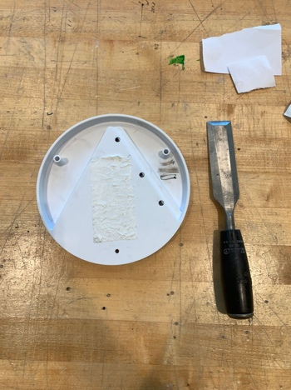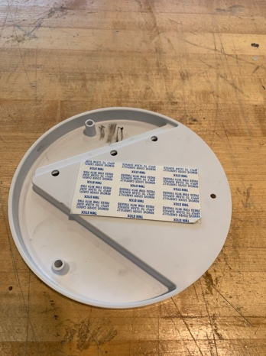

Figure 49: The Device with Adhesive Removed

Figure 48: The Device with Adhesive Attached

1. 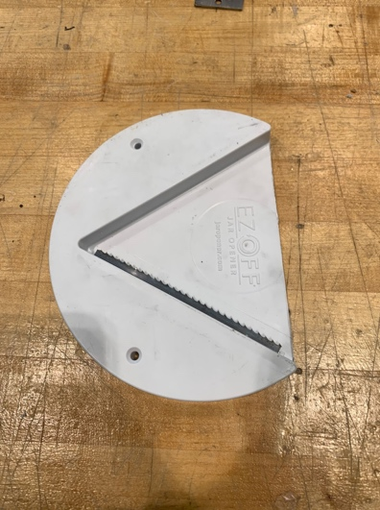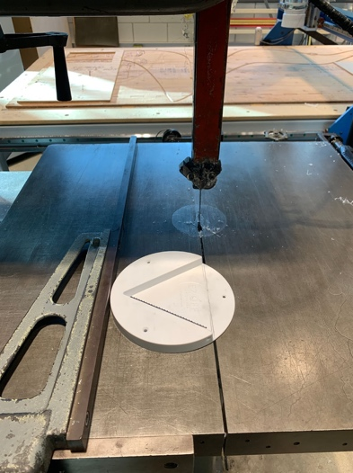Using a ruler and pencil, draw a horizontal line across the V opening of the opener on the side with the metal blade (see Figure 50). Place the device with the adhesive side down on the base of the vertical band saw as seen in Figure 50 and cut on the line drawn (see Figure 51).

Figure 50: The Device with Specified Line

Figure 51: The Device with Extra Material Removed

1. Optional: If desired run the cut edge of the device on the vertical belt sander to smooth it to a desired finish (see Figure 52). This step is purely from an aesthetic desire and does not impact the functionality of the device.

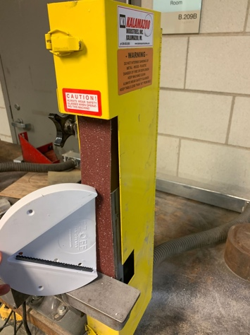

Figure 52: Sanding the Device

1. 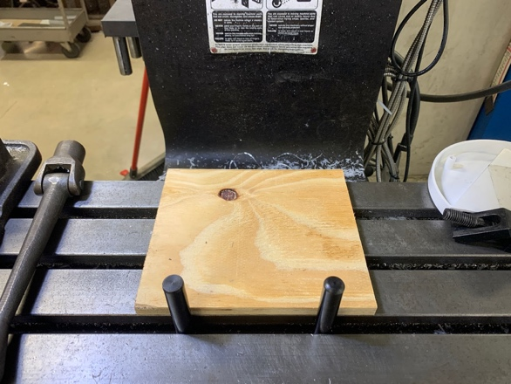Now bring the device and the plywood to a manual mill. If applicable, remove the mill vise so that there is only the mill base. Place two table pins 5” apart on the closest mill grove, so that the cut plywood piece can fit securely against them (see Figure 53).

Figure 53: The Plywood Block Flush on Mill Pins

1. Select two 6” studs and their corresponding T-Nuts that correspond to the diameter of the t-slots on your mill (see Figure 56). Place the T-Nuts and the studs in the t-slots, and run them across the mill table until they are evenly spaced so that there is enough room to place the plywood in between them and against the pins (approximately 2” on the outer edge of each pin as seen in Figure 55)
2. Place the plywood in between the studs and flush against the pins. Adjust the studs if needed by sliding them in the t-slots so that the plywood is securely in place.

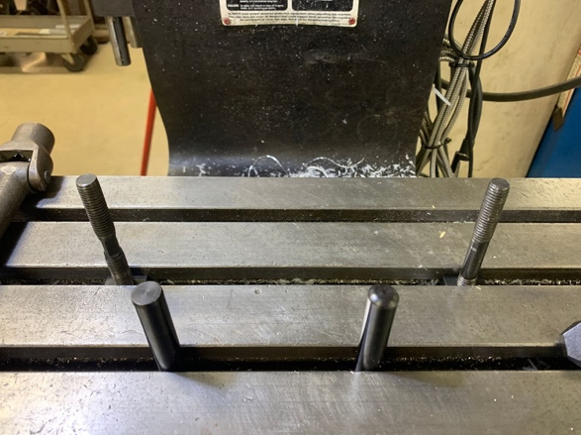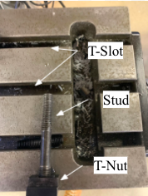

Figure 55: Mill Studs and Pins in Place

Figure 54: Labeled Mill Parts

1. 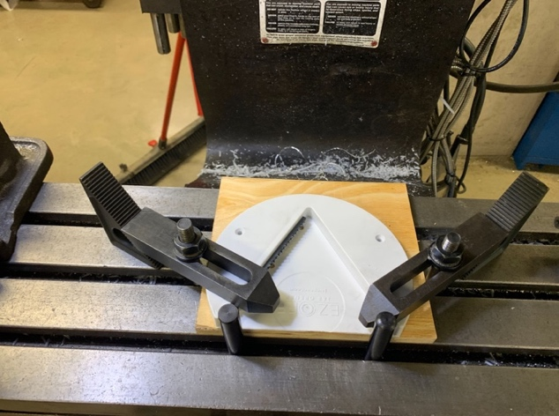Now place the device on top of the plywood, bottom side (side with the metal blade) facing up so that the cut end is flush with the pins as well (see Figure 56); the device should be roughly in the center of the plywood, but deviations can take place if needed. Finally, thread a large step bar, as seen in Figure 56, through the stud and angle the step bar towards the pin so that one end rests on the elevated portion of the device towards each tip of the V. Secure the other end of the step bar with the step block (as shown in Figure 57) making sure that the grooves are firmly interlocked with each other. Once secured, screw in a flange nut on the top of each stud with a the appropriately sized wrench to ensure that the device 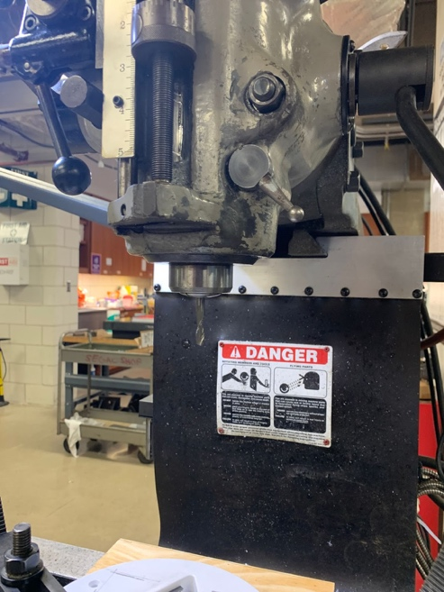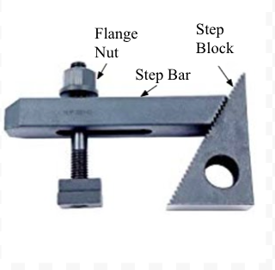is firmly clamped in place (see Figure 58)

Figure 56: The Device Clamped into the Mill

Figure 58: The End Mill in the Mill

Figure 57: Labeled Mill Clamping Parts

1. Insert a ¼” mill faster and ¼” mill bit into the mill (see Figure 58). Adjust the mill speed setting to a feed of 700ft/min and feed to .007 in/rev.
2. Once the drill bit is inserted and the device is firmly clamped down, you can begin to mill. First adjust the height of the mill so that the end mill can go all the way through the device (adjustments depend on the type of mill so consult the mill manual if necessary).
3. Next, align the end mil with the left precut hole. Zero the mill (see Figure 59). Now move the mill table 0.6” in the y direction (x = 0.0000, y = -0.6000) on the mill screen. Zero the mill again (see Figure 59). This will be the zero position for the rest of the cuts.
4. 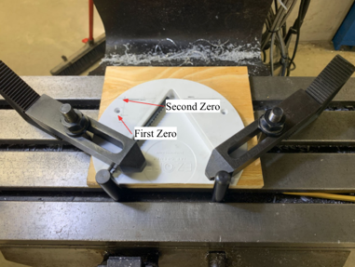You can now begin cutting the device. Turn the mill on and ensure that it is cutting in the forward direction. Starting in the zeroed position, bring down the end mill until it has fully cut through the plastic. Begin moving the mill table in the positive x direction, for exactly 1.05” (x = 1.0500, y = 0.0000). With the mill still on and the end mill still down, move the mill table back to the zero position (x = 0.0000, y = 0.0000). Repeat back and forth, if necessary, until a satisfactory smooth cut has formed (see Figure 60).

Figure 59: The Initial Zero Points

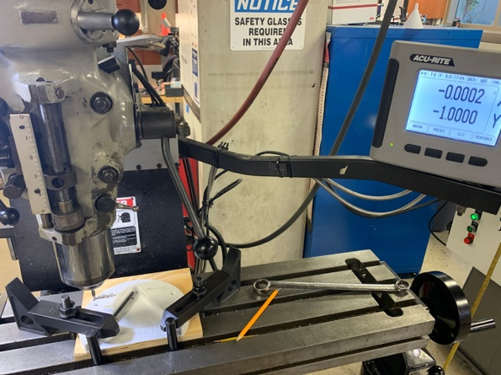

1. Bring up the end mill and turn the mill off. From the zeroed position move the mill table 5.5” in the x direction (x = 5.5000, y = 0.0000). Repeat step 12 above except in this new position; however, do not zero the mill again. Simply move the mill table 1.05” again in the positive x direction (reaching x = 6.5500, y = 0.0000) and then return to the starting position (x = 5.5000, y = 0.0000).

Figure 60: Milling the Device

1. Bring up the end mill and turn the mill off. Return the mill to the zero position. Now, move the mill 1” down in the positive y direction (x = 0.0000, y = 1.0000). Once again, follow step 12 to make a new cut in the new position; as before, do not zero the mill. Rather, move the mill 1.05” in the x-direction going to (x = 1.0500, y = 1.0000) before returning to the starting position.
2. Finally, extract the end mill and turn the mill off. Repeat step 13, except using this new position, cutting from x = 5.5000, y = 1.0000 to x = 6.5500, y = 1.0000. Once complete, extract the end mill and turn the mill off. You have completed all the required cuts as seen in Figure 63.

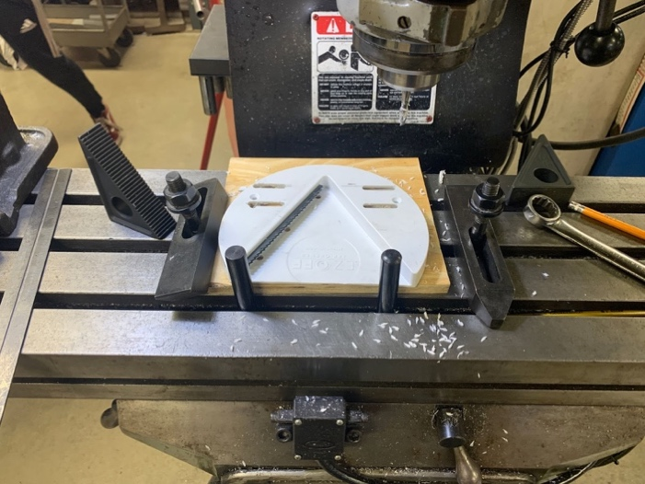

Figure 61: The Finished Milled Device

1. Remove the device from the mill and restore the mill to its original state. If desired, use a file or sandpaper to smooth the four slots.
2. Cover the metal teeth with painter’s tape as seen in Figure 62.

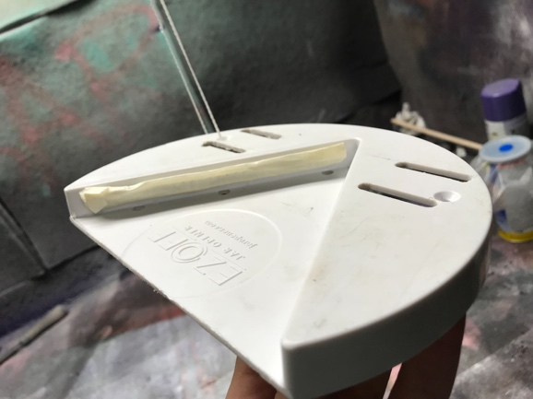

Figure 62: Preparing the Device for Painting

1. Hang it inside of a fume hood or an open space where air can flow as seen in Figure 63. Because it is a 3-dimensional object, hanging it allows for rotation to occur to provide a full even coat. Spray paint it with black or grey paint (see Figure 64).

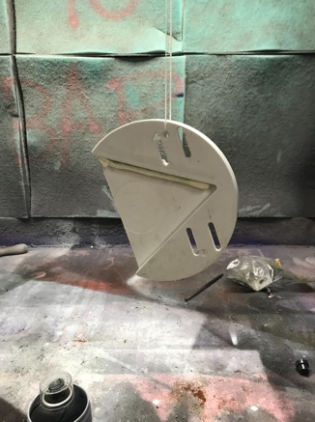

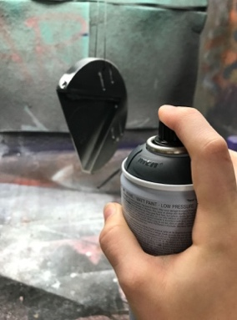

Figure 63: The Device Hanging

Figure 64: Spray Painting the Device

1. Leave to dry and give a second coat.
2. As each unique wheelchair has unique armrests, the Velcro straps need to be adjusted to the desired length. First measure the circumference of the wheelchair arm. In order to account for the Velcro material looping through the device, and the sewing of the end piece, add 2 inches to the circumference.
3. Measure the Velcro strap from the plastic loop piece to the calculated length in step 20. Cut the strap at this length and cut the strap where two parts of Velcro meet (the soft part and gripping part).

1. Overlap by 1 inch the first cut Velcro piece with the second cut Velcro piece, so that the two pieces are stuck together. Now, sew the overlapping two pieces together using either a sewing machine or hand sewer.
2. Pass the Velcro through the previously drilled holes, as shown by the Figure 65 then loop them through the plastic rectangles.

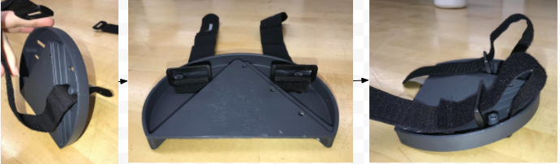

Figure 65: Passing the Velcro Straps through the Device

1. Attach the Velcro back to itself and the product is ready to be added to an armrest and used, as shown in Figure 66.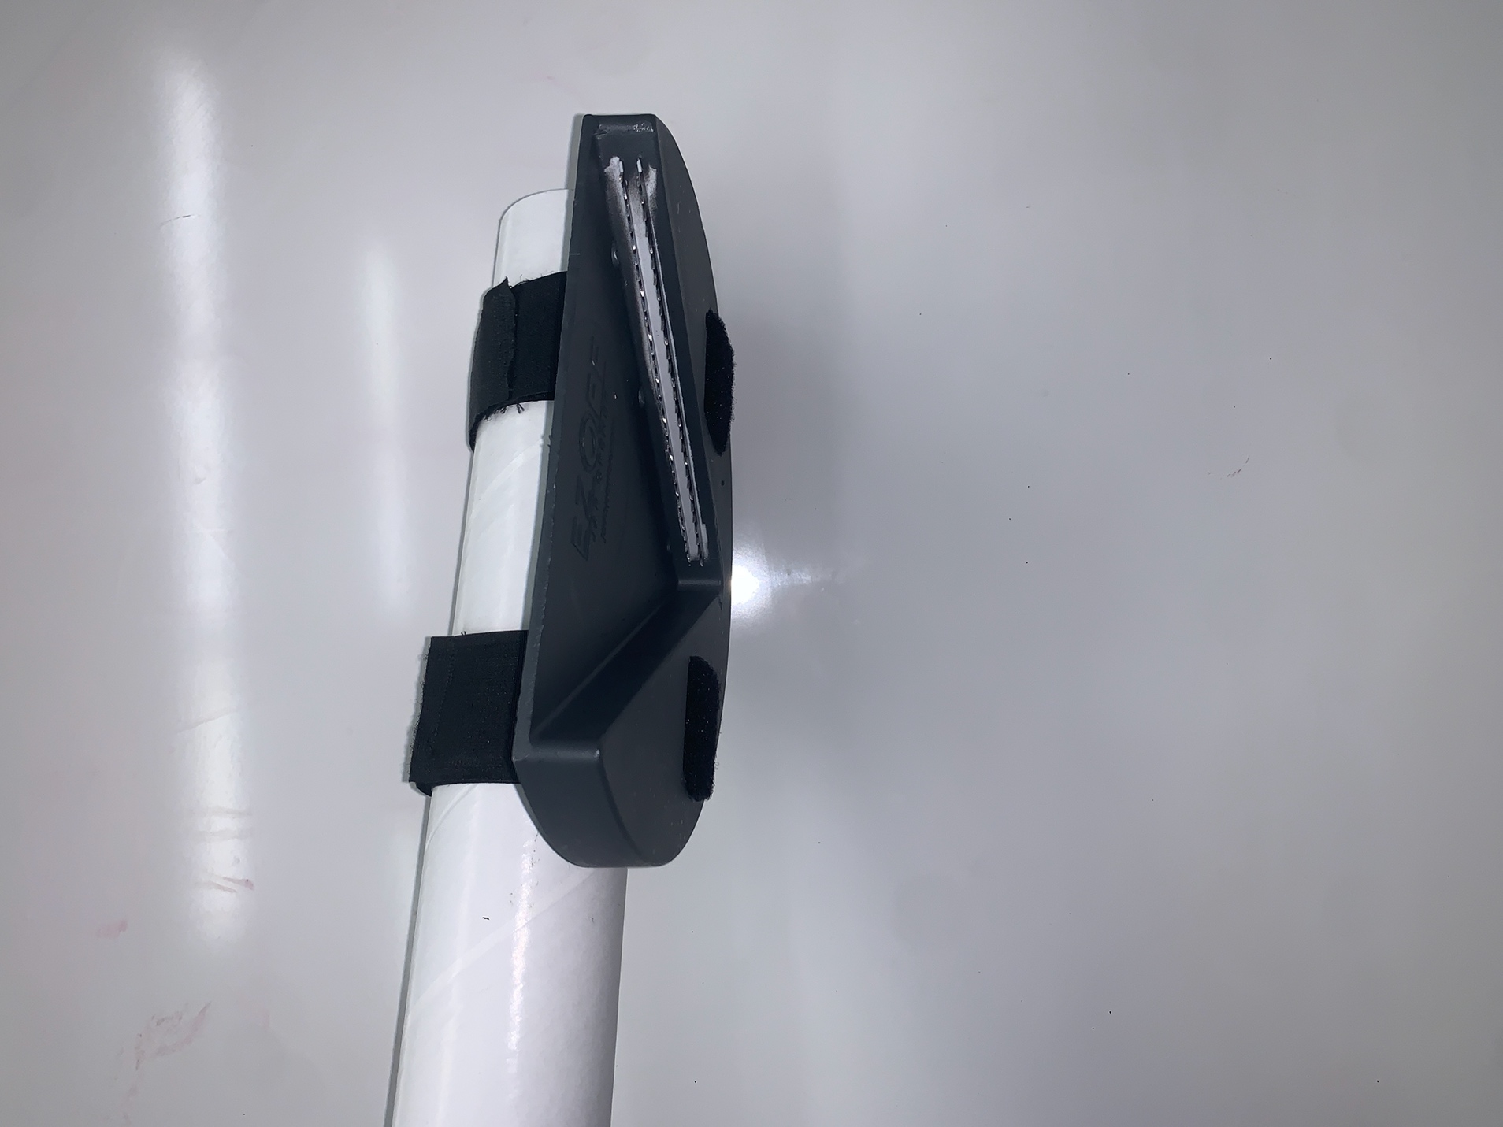

Figure 66: The Finished Product

## Bill of Materials

Table 5: Bill of Materials for Mockup Testing

|  |  |  |  |  |  |
| --- | --- | --- | --- | --- | --- |
| Item | Description of Purchase | Qty | Source | Part number | Cost |
| EZ Off Jar Opener | EZ OFF Jar Opener®: EZ Off will grab hold of any lid whether its factory sealed, child proof, tamper proof or just stuck from what's inside the jar. A simple twist and The EZ Off Jar Opener will deliver | 2 | [Amazon](https://www.amazon.com/EZ-Off-Opener-Sizes-White/dp/B000X6K9J8) | B000X6K9J8 | $14.87 each, $29.47 total |
| Envisioned Velcro Straps | Envisioned Velcro Straps: Constructed of durable, strong gripping hook and loop nylon material, these adjustable, reusable, and multi-purpose cinch straps are easy to use and hold strong! Perfect for organizing and securing items in your home, garage, office, vehicle, for camping and outdoors. | 1 | [Amazon](https://www.amazon.com/Reusable-Cinch-Straps-30-Multipurpose/dp/B01G4IVLC2/ref=sr_1_16?keywords=velcro%2Bloop%2Bstraps&qid=1636670810&qsid=143-9282443-7067840&sr=8-16&sres=B0798L21FG%2CB08MZYWQ3L%2CB001E1Y5O6%2CB07SMD8QVH%2CB00JWU77N2%2CB00006IC2R%2CB07CZGQNY3%2CB08JQ6XWR2%2CB07FMTZ5RM%2CB097BG9Q9F%2CB00QMMKY8I%2CB07GTV7PJK%2CB07FY7T1WL%2CB08PK7ZXBX%2CB079BGB97Z%2CB0721RLH3V&th=1) | B01G4IVLC2 | $15.87 |
| Total Cost: | | | | | $45.61 |

# Appendix F: Stress Testing

We want to design MiCO to last for as long as possible, and thus we went through a strenuous process to find the most suitable materials for our solution, attempting to find the highest-quality materials while keeping manufacturing and market costs low (see Appendix E: Bill of Materials). This meant that with every material we tested, we ran Finite-Element-Analysis (FEA) tests for the overall assembly.

Note: although most of our report is in imperial units, the following stress tests were conducted in metric units due to SolidWORKS’ default settings. This section, “Stress Testing,” will include measurements given in both imperial and metric units.

For our FEA simulations, we chose the materials as follows: PEEK plastic for the base, steel alloy for the blades, and rubber (the most similar material to Velcro in SolidWORKS, our chosen CAD software) for the straps. FEA tests help determine mechanical stress, fatigue, and motion, among other physical effects, all of which vary from material to material [8]. We conducted two tests: one to determine whether MiCO would fracture or not under normal use, and another to determine the displacement of MiCO’s material after repeated uses with an applied force. The ensuing tests are only for MiCO’s assembly, and not the protective sleeve.

To conduct these tests, we first had to define where force would be applied onto MiCO. Forces present include on the point of contact of the Velcro straps with the armrest (a normal force), an equal and opposite force onto MiCO from the armrest, and the force of the user opening their container with MiCO. Sheffield Hallam University in the United Kingdom conducted a study on torque and the elderly and determined that a range of 2.14 to 4.06 Feet-pound (lbf-ft), or 2.9 to 5.5 Newton-meters (N-m), of torque would be sufficient to open a jar [9]. Using the higher end of this range (4.06 lbf-ft, 5.5 N-m) and the equation for torque (τ=F⋅r, where τ is torque in N-m, F is the force applied in Newtons, and r is the length of the lever arm in meters), we approximated the maximum force the user would need to apply to open a container with MiCO is approximately 11.24 Pounds-Force (lbf), or 50 Newtons.

The results of the first test are as shown in Figure 66.

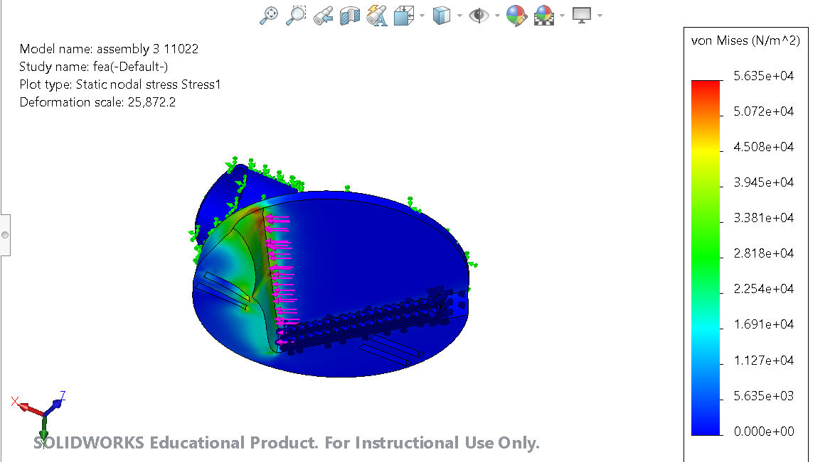

Figure 66: The Force Distribution FEA Test on MiCO

The units of this stress test, given in metric units as opposed to imperial units, is a value used to determine whether a given material or assembly will yield or fracture under duress. The coefficient of safety which is the ratio of material strength to maximum stress should ideally be greater than one [29]. In our case, it is 1.066e+03 von Mises (N/m^2) and thus, our assembly and choice of materials will not buckle under a predetermined number of forces.

Another FEA test we conducted measured the displacement of material of MiCO if the user continuously used MiCO. The displacement of MiCO (at the high end, 0.0007117 mm or 2.82e-05 inches, as seen in Figure 67) is minimal, and with the data obtained from the first FEA test, we can conclude that MiCO, with its chosen materials and designs, could effectively withstand the pressures and forces that would arise from everyday use.

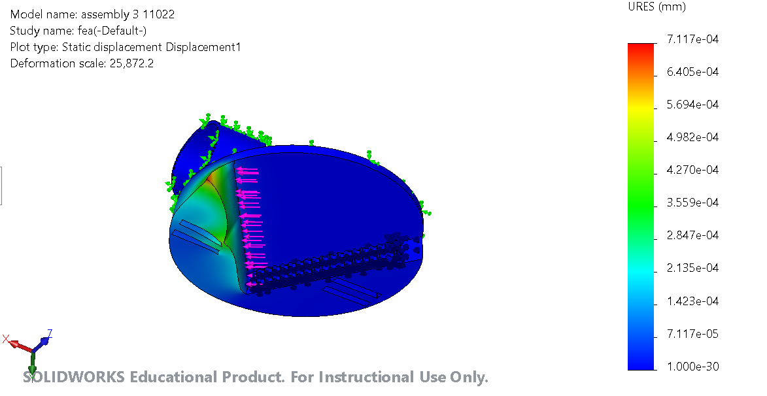

Figure 67: The Results of the Displacement test on the MiCO assemble

# 

# Appendix G: Mockup Consultation

## Mockup Consultation 1: Interview with Heidi Huckabay

### Methodology

On Monday, October 18th, 2021, the team held an in-person meeting with shop expert Heidi Huckaby, a prototyping specialist at the Segal Design Institute at Northwestern. The objective of this meeting was to get insight on mockup design, including material choice, fabrication methods, and questions regarding functionality. Team members presented their initial mockups to her and sought insight on the topics.

### Initial Commentary

The team explained the overall nature of the project and limiting factors and considerations when devising a solution. The team then gave a quick overview of the research conducted so far in addition to previous solutions under considerations. With a firm background established, the team then moved on to mockups.

### Mockup Overview

Heidi emphasized that mockups, especially in the early stages of design, need not be entirely complex. She recommended using cardboard, foam board, and other simple materials found throughout the shop to make the initial mockups. She then gave us a brief tour of the shop, informing us where these materials and tools are located for initial mockups. This tour was particularly insightful in relation to informing us about the cabinets in the backroom of the shop which contains more specialized hardware that might significantly improve our mockups.

### Mockup Review

The team then presented Heidi with some initial mockups in preparation for our meeting with the professors on the following day. Each team member explained the initial idea of their mockup in addition to a sketch of it. For each mockup, Heidi made some material in addition to overall design commentary. In review of Ahmad’s mockup, she pointed out the potential for a conical shape design to get a more versatile gripping mechanism for the containers. Furthermore, she then also observed the large potential for overlap between each team member’s proposed mockups, which sparked a discussion on collaboration between our mockups. Both insights were incredibly helpful for our team as we underwent the mockup fabrication portion of our project. We then discussed future steps for mockups, including mockup testing and finally finished the meeting by discussing future availability for another consultation.

# Appendix H: Performance Testing

## Prototype Testing 1

## Introduction

We will refer to the following testing guide with users and other stakeholders as they perform tasks with our mockups.

Difficulties with testing arose from the fact that the intended user, Igor, is not easily accessible (due to the COVID-19 pandemic). Thus, any user-testing will occur through consulting with the occupational therapists at Shirley Ryan AbilityLab, Meghan and Randi, or through simulated trials with respondents (proxy users) who do not have the same injuries and limitations as Igor.

Our goals are (1) to learn whether our prototype is practical and functional, and (2) learn how easy or difficult it is to utilize the prototype given various containers of different sizes and limitations

## https://lh4.googleusercontent.com/V10BvAqjcd7g_T2URoqyNxPnxOvIIFRFS3W7x1TVE6BsPvbGw5kkA4pxSHAFd0grcVdSu8kAS9f2e5hffPSoi7AglxZ9CAMFPL6CE3ejKmAQZPl25wAGWH9-89-qb66yg6ICbiWPMethodology

Our proxy user trial will attempt to simulate some of the limitations that Igor has. The seat used for the trial simulates that of Igor’s wheelchair by having a similar distance between the armrest and bottom of the chair (about 7”). We then attach the prototype to the seat using a cylindrical tube that fits over the armrest (see Figure 698; this allows the first strap of the prototype to be placed 10” away from the near edge of the wheelchair (the width closer to the user) which is the intended spot for the prototype. During our trial, our proxy user will be sitting down in the seat, with their left arm resting on top of the left arm rest (with the prototype attached below) and their right arm in use. They will then perform a series of tasks with the prototype and provide their written feedback after each task.

Figure 68: Chair Used as Testing Mechanism

## Task One: Large Jar

Opening Peanut Butter Jar and Jam Jar (Large Diameter Containers as seen in Figure 69):

1. Remain seated and place your left hand on the left armrest.
2. Using your right hand, grab the jar from the table and insert the lid into the V-shaped opening of the opener.
3. Twist the jar clockwise until the lid is loosened.
4. Remove the jar and place it back on the table.
5. Now open the lid of the jar with your right hand, proving the loosened state.

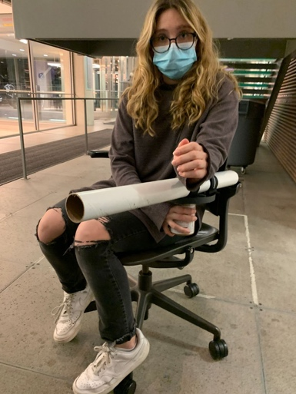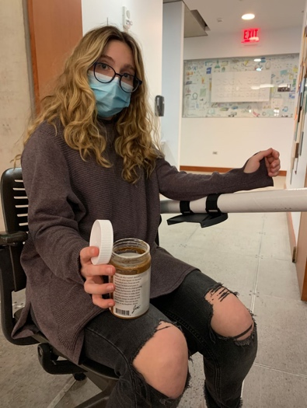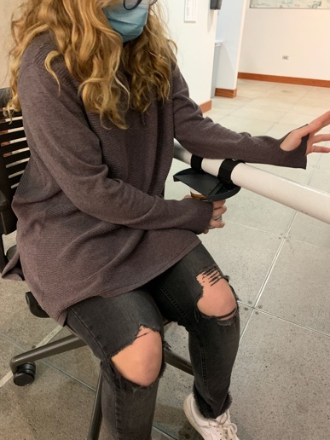

Figure 35:

Figure 69 :Sequence of Opening the Large Diameter ContainerFigure 35:

Figure 69 :Sequence of Opening the Large Diameter Container

## Task Two: Medium-Sized Container

Opening Spice Jar (Medium Diameter Containers as seen in Figure 70):

1. Remain seated and place your left hand on the left armrest.
2. Using your right hand, grab the spice jar from the table and insert the lid into the V-shaped opening of the opener.
3. Twist the jar clockwise until the lid is loosened.
4. Remove the jar and place it back on the table.
5. Now open the lid of the jar with your right hand, proving the loosened state.
6. 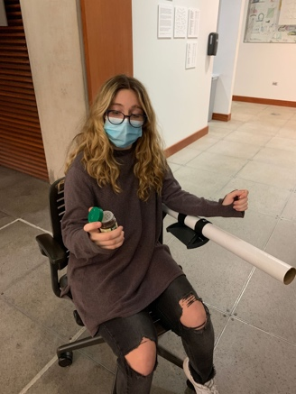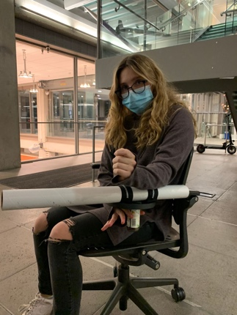Please fill out the table below for the respective category.

Figure 70: Sequence of Opening the Medium Diameter Container

## Task Three: Pill Bottle

Opening Pill Bottle (Small Diameter Container, as seen in Figure 71)

1. Remain seated and place your left hand on the left armrest.
2. Using your right hand, grab the pill bottle from the table and insert the lid into the V-shaped opening of the opener.
   * Note: If required, push the pill bottle jar firmly up to ensure the child safety opening mechanism for the lid is disengaged
3. Twist the jar clockwise until the lid is loosened.
4. Remove the jar and place it back on the table.
5. Now open the lid of the jar with your right hand, proving the loosened state.
6. 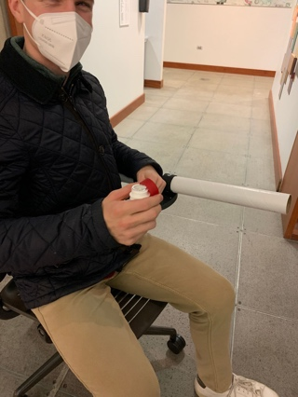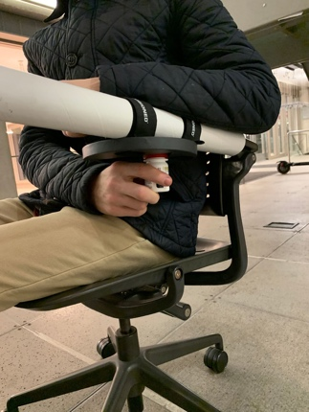Please fill out the table below for the respective category.

Figure 71: Sequence of Opening the Small Diameter Container

Table 6: Performance Testing Summary

|  |  |  |  |  |  |
| --- | --- | --- | --- | --- | --- |
| Tasks | Effectiveness | Time | Easiness of use | Prototype Malfunctions | Additional comments/ concerns |
| 1: Peanut Butter Jar, Jam Jar (Large Diameter Container) | -The prototype is effective; the jar was opened successfully multiple times. | 2 seconds approximate average | -The product was accessible and intuitive.  -The top just slides in and with just one twist the hardest part is over.  -The most challenging part was opening the container completely with our fingers to finish the opening job, which requires some fine motor skills, but still seems accessible. | No malfunctions during testing. | -No additional comments. |
| 2: Spice Jar (Medium Diameter Container) | -The prototype is effective; the jar was opened successfully multiple times. | 1.77 seconds approximate average | -Very easy to use and open. Required little force and the lid easily came off. | -No malfunctions during testing. | -No additional comments. |
| 3: Pill Bottle (Small Diameter Container) | -The prototype is effective; the jar was opened successfully multiple times. | 8.23 seconds  approximate average | - It required some tries to get the proper motion, but after we understood how it was supposed to twist with the child lock, it proved useful and easier to use. | - The prototype slipped a little due to the greater upward force required to open the pill bottle. The circular tube that the prototype was attached to contributed to the slippage while a more rectangular shape, like the user’s armrest, might not result in said scenario. | -It was more difficult to open, requiring a higher amount of force upwards against the top of the device.  - We can also acknowledge the fact that the user can have their nonfunctional arm as a counterweight on top of the armrest to ensure that the armrest doesn’t move upwards.  - Finally, different pill bottles have different child safety mechanisms which make their lids harder to open. Although our model works with the push down safety mechanism, others including pushing in on each side of the lid might not be manageable with the prototype. |

# Appendix I: Design Review Summary

## Design Review 1: Feedback

### Methodology

We shared our design, MiCO, my instant container opener, a product that enhances the capabilities of the under the counter opener, in class on Date and time. We explained how MiCO attaches to the wheelchair with a Velcro strap that is looped for easy application and removal. It has a V-shaped opening and steel teeth that allow for efficient and versatile use.

The reviewers were given a questionnaire to answer questions about specific areas of the design to build a more solid concept. Questions focused on accessibility and easiness of use, as well as the most effective method of attachment to the wheelchair, and the limitations that the product could have.

Table 7: Design Review Summary

|  |  |  |  |  |
| --- | --- | --- | --- | --- |
| Reviewers like | Reviewer’s dislike | Features to be added | Features to be removed | Additional comments/ questions |
| The accessibility of the design  It is straightforward and easy to use.  The detachable feature  The fact that it is removable with ease  **Its effectiveness** Because it is an enhances product based on one that works, it seems like it will be useful | The safety factors  How it will be stored to prevent danger to the user  The comfort of the motion  The position of the device might not be optimal for comfort for the user  Where the lids go  The product may cause a lid to fall off causing a further inconvenience | A cap or a case to prevent danger to the user. It must be easy to place with one hand.  The position of the device may be modified and put diagonally in front, but performance testing is required  The device could hold the cap in place, but it is meant to break the seal and make it easier to open with one hand, without removing the cap | The plastic could be not sturdy enough, so it could be a factor to replace and consider another material  We narrowed down that it will be attached with looped Velcro, which means that rubber clamps or adjustable zip ties will no longer be considered for use. | There should be performance testing to see if it will slide down the arm and to make sure it is secure and easy to use.  How will the Velcro attach to the device itself?  Does it extend past the wheelchair? How would the size be adjusted? |

### Plan to address these reviews

There will be performance testing with the product. Multiple EZ container openers will be bought in order to be able to choose the most effective and efficient product from a variety of methods of attachment and positions relative to the wheelchair. We will also develop a cover or a case that will ensure the safety of the user. The reviewers agreed that the looped Velcro was the best way to attach the device, but we still must determine what the optimal position and attachment to the device itself is. We will achieve this by testing different methods, like drilling the plastic or a superglue epoxy. If the comfort of the motion is not optimal, we will adjust the position by adding an extension to the wheelchair arm or develop another method of keeping MiCO sturdy while keeping the user comfortable. Regarding the size, we have a plan to reduce it and it would not stick outside of the arm rest.

# References

## Main Report

[1] https://www.amazon.com/Dycem-Non-Slip-Material-Roll Blue/dp/B000C23XJG/ref=sr_1_1?keywords=dycem&qid=1638398984&sr=8-1

[2] https://www.amazon.com/Electric-Opener-Kitchen-Gadget-Automatic/dp/B07SN8KFHM/ref=sr_1_3?crid=2MCFAPCDJ0SIH&keywords=automatic+jar+opener&qid=1638399039&sprefix=automatic+jar+op%2Caps%2C174&sr=8-3

[3] https://www.amazon.com/EZ-Off-Opener-Sizes-White/dp/B000X6K9J8/ref=sr_1_2?crid=176A40D8V721A&keywords=ez+off+jar+opener&qid=1638399049&sprefix=ez+off+%2Caps%2C205&sr=8-2

[4] https://www.amazon.com/Butter-Justins-Ingredients-Gluten-free-Responsibly/dp/B07DDWCHJP/ref=sr_1_5?keywords=peanut+butter+jar&qid=1638399077&rdc=1&sr=8-5

[5] https://www.amazon.com/Freshmint-Flouride-Toothpaste-Count-Ounce/dp/B00CGXDPKG/ref=sr_1_13?keywords=toothpaste+tube&qid=1638399104&sr=8-13

[6]: https://omnexus.specialchem.com/selection-guide/polyetheretherketone-peek-thermoplastic

[7]: https://www.designnews.com/automation-motion-control/titanium-alloy-edges-out-peek-custom-cranial-implant

[8]: https://www.autodesk.com/solutions/finite-element- analysis#:~:text=Finite%20element%20analysis%20(FEA)%20is,flow%2C%20and%20other%20physical%20effects.&text=It%20is%20called%20analysis%2C%20but,when%20the%20product%20is%20used.

[9]: https://shura.shu.ac.uk/9128/1/Yoxall_Talking_about_Torgue.pdf

[10]: https://feaforall.com/calculate-safety-factor/

## Appendix B:

[B1] “BIOMECHANICS OF THE HAND.” https://ouhsc.edu/bserdac/dthompso/web/namics/hand.htm (accessed Oct. 07, 2021).

[B2] “Body Anatomy: Upper Extremity Muscles | The Hand Society.” https://www.assh.org/handcare/safety/muscles (accessed Oct. 07, 2021).

[B3] P. Goetti, P. J. Denard, P. Collin, M. Ibrahim, P. Hoffmeyer, and A. Lädermann, “Shoulder biomechanics in normal and selected pathological conditions,” EFORT Open Rev., vol. 5, no. 8, pp. 508–518, Sep. 2020, doi: 10.1302/2058-5241.5.200006.

[B4] N. Jacewicz, “Millennials May Be Losing Their Grip,” NPR, Jun. 13, 2016. Accessed: Oct. 07, 2021. [Online]. Available: https://www.npr.org/sections/health-shots/2016/06/13/481590997/millennials-may-be-losing-their-grip

[B5] “Grip and Manipulation,” p. 9.

[B6] “Osteoarthritis - Diagnosis and treatment - Mayo Clinic.” https://www.mayoclinic.org/diseases-conditions/osteoarthritis/diagnosis-treatment/drc-20351930 (accessed Oct. 07, 2021).

[B7] L. E. Jones-Engel and K. A. Bard, “Precision grips in young chimpanzees,” Am. J. Primatol., vol. 39, no. 1, pp. 1–15, 1996, doi: 10.1002/(SICI)1098-2345(1996)39:1<1::AID-AJP1>3.0.CO;2-2.

[B8] “Arthritis | CDC,” Nov. 03, 2020. https://www.cdc.gov/chronicdisease/resources/publications/factsheets/arthritis.htm (accessed Oct. 07, 2021).

[B9] “The Known and Unknown of Stroke Infographic,” *www.stroke.org*. https://www.stroke.org/en/professionals/stroke-resource-library/post-stroke-care/the-known-and-unknown-of-stroke-infographic (accessed Oct. 07, 2021).

[B10] “Stroke Information Page | National Institute of Neurological Disorders and Stroke.”

https://www.ninds.nih.gov/Disorders/All-Disorders/Stroke-Information-Page (accessed Oct. 11, 2021).

[B11] “Post-Stroke Rehabilitation Fact Sheet | National Institute of Neurological Disorders and Stroke.” https://www.ninds.nih.gov/Disorders/Patient-Caregiver-Education/Fact-Sheets/Post-Stroke-Rehabilitation-Fact-Sheet (accessed Oct. 07, 2021).

[B12] L. Rasulić *et al.*, “MANAGEMENT OF BRACHIAL PLEXUS MISSILE INJURIES,” *Acta Clin Croat*, vol. 57, no. 3, pp. 487–496, Sep. 2018, doi: 10.20471/acc.2018.57.03.12.

[B13] “Brachial Plexus Injuries Information Page | National Institute of Neurological Disorders and Stroke.” https://www.ninds.nih.gov/Disorders/All-Disorders/Brachial-Plexus-Injuries-Information-Page (accessed Oct. 07, 2021).

[B14] M. M. Samardzic, L. G. Rasulic, and D. M. Grujicic, “Gunshot injuries to the brachial plexus,” *J Trauma*, vol. 43, no. 4, pp. 645–649, Oct. 1997, doi: [10.1097/00005373-199710000-00014](https://doi.org/10.1097/00005373-199710000-00014).

[B15] “Occupational Therapy,” Dycem. https://Dycem-ns.com/occupational-therapy (accessed Oct. 07, 2021).

[B16] “Opening Jars with Arthritis: 21 Tips from Occupational Therapists to Make It Easier,” CreakyJoints, Jan. 07, 2020. https://creakyjoints.org/living-with-arthritis/how-to-open-jars-with-arthritis/ (accessed Oct. 07, 2021).

[B17] tel-editors, “Best Jar Opener for Older Adults,” Tech-enhanced Life, Oct. 14, 2015. https://www.techenhancedlife.com/explorers/best-jar-opener-older-adults (accessed Oct. 07, 2021).

[B18] “Automatic Jar & Can Openers | Disability Network Southwest Michigan,” Feb. 08, 2016. https://www.dnswm.org/automatic-jar-can-openers/ (accessed Oct. 07, 2021).

[B19] Pamolon, Round Silicone Trivets, model: YQ-1250.

[B20] Mondolfo, L. F. Aluminum Alloys: Structure and Properties. Elsevier, 2013.

[B21] Saravanan Murugan, Dhrumika Patel, Kinjal Prajapati, Madhuri Ghoghari, Pranjali Patel. Grip strength changes in relation to different body postures, elbow, and forearm positions. Int J Physiother Res 2013; 04:116-21.

[B22] J. Owen, Degradation and Stabilisation of PVC. Springer Science & Business Media, 2012.

[B23] S. C. Shit and P. Shah, “A Review on Silicone Rubber,” Natl. Acad. Sci. Lett., vol. 36, no. 4, pp. 355–365, Aug. 2013, doi: 10.1007/s40009-013-0150-2.

[B24] S. Derler, R. Huber, F. Kausch, and V. R. Meyer, “Effectiveness, durability and wear of anti-slip treatments for resilient floor coverings,” Safety Science, vol. 76, pp. 12–20, Jul. 2015, doi: 10.1016/j.ssci.2015.02.002.

[B25] “What noises cause hearing loss?,” *Centers for Disease Control and Prevention*, 07-Oct-2019. [Online]. Available: https://www.cdc.gov/nceh/hearing_loss/what_noises_cause_hearing_loss.html. [Accessed: 14-Oct-2021].